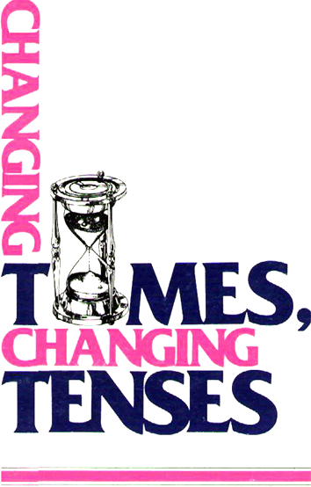

PATRICIA WILCOX PETERSON

A REVIEW OF THE ENGLISH TENSE SYSTEM

Introduction
This book is a review of the relationships between times and tenses in English. It is intended for beginning and intermediate level language students in non-English speaking countries, as a reinforcement and addition to their regular structure classes. The chapter dealing with each tense may be used as soon as the students have covered that tense in their formal grammar study. Alternatively, the teacher may want to present certain groups of tenses together if the student seems to be having trouble with a particular concept; for instance, he could teach all the perfect tenses or all the continuous tenses together.
The English tense system is quite complicated, but the most common problem is not how to form tenses. The mechanical manipulation of verbs is easily learned through a few rules and formulas. The biggest problem is deciding which tense to use in a given situation. In order to choose correctly and easily, the student must understand the meaning of the tense itself, its time picture or time line. He must know what kinds of activities and states can be described by certain verbs. Certain groups of verbs are limited in their usage, and this can present problems, too. Finally, the student needs to be able to choose accurate time markers to clarify the time picture.
In response to these problems, this book has as its goals:
1. to present clear time lines for each tense
2. to introduce categories of verbs which act in certain ways: punctual verbs, durative verbs, and non-continuous verbs
3. to teach the proper use of time markers to show points in time, frequency, and duration for each tense.
Because this is a supplementary text, it is suggested that the teacher use it for short periods of time. Ten or fifteen minutes per day is long enough. In that amount of time, students can work with the reading selection and one or two exercises. One chapter may take two or three days to finish at this rate.
The vocabulary for the book is based on the 1000-word level as given in The New Horizon Ladder Dictionary of the English Language, by John Robert-Shaw, Popular Library. When it was necessary to use words from a higher word level, they have been given as vocabulary items at the beginning of the chapter. The teacher may want to pre-teach these words before going on to the reading selection. In most cases these less frequent words were chosen because they are represented in the picture; accordingly, their meaning should be easy to understand from the picture.
The pronunciation exercises provide the normal spoken reduced forms for standard American English. When these forms have been accepted in written form as contractions, they are contracted in the text. When they are not written, but only spoken forms, they are not contracted in the text. However, even the reduced forms are commonly used by educated speakers. They are not slang. The teacher may use them in the chapter readings and exercises, even when the printed form itself doesn't reflect these reductions. For example, in chapter five, the spoken form for what is is given as /wet s/; in the next chapter, a question following the reading selection is, “What is hanging like a brown cloud over New York today?” Although the written form shows two words, the teacher may safely reduce them to /wet s/. All phonetic notations conform to the International Phonetic Alphabet.
Finally, this book is meant to be used primarily for aural/oral activities. Read the selections aloud. Have the students pronounce all the words, repeating in phrases. Do the questions and exercises aloud, with books closed. (It may help to draw the correct time line on the board as well, as an additional memory aid.) Encourage the use of role-playing and dialogues, and give the students many opportunities to use all the tenses in their speaking activities. The exercises entitled Changing Times, Changing Tenses are comparatively unstructured. They provide the student with an opportunity to pick the correct tenses in free conversation. Such practice is lecessary if the student is to achieve the ultimate goal, that of choosing and using the correct tense easily.
My thanks go to the people in the photo library of the Denver Post, who helped me find most of the pictures for the book. It was a long process. It is my hope that the people who use this book will find the pictures as interesting as I did, and that the pictures will stimulate lots of discussion!

Changing Times, Changing Tenses

A Review of the English Tense System

Patricia Wilcox Peterson

TABLE OF CONTENTS
PATRICIA WILCOX PETERSON 1
A REVIEW OF THE ENGLISH TENSE SYSTEM 1
Introduction 1
Changing Times, Changing Tenses 3
A Review of the English Tense System 3
Patricia Wilcox Peterson 3
TABLE OF CONTENTS 3
Unit One: The Present Tense 5
chapter one LITTER IS A PROBLEM IN OUR CITIES 5
chapter two PEOPLE WORK AT MANY DIFFERENT JOBS 8
chapter three HANDICAPPED PEOPLE DO USEFUL WORK 15
chapter four HALLOWE'EN IS A HOLIDAY FOR CHILDREN 17
Unit Two: The Present Continuous Tense 19
chapter five THE KITES ARE FLYING HIGH 19
chapter six POLLUTION IS SPOILING THE AIR YOU BREATHE! 21
Unit Three: The Present Perfect Tenses 25
chapter seven THIS WOMAN HAS LOST HER JOB 25
chapter eight IT'S DIFFICULT TO SAY GOOD-BYE 27
chapter nine ARE BUSES AS EASY TO USE AS CARS? 30
Unit Four: The Past Tense 32
chapter ten LIGHTNING STRUCK THE CITY LAST NIGHT 32
chapter eleven RESCUE WORKERS SAVED FOUR PEOPLE 34
chapter twelve DINOSAURS LIVED MANY YEARS AGO 38
chapter thirteen DRY LAND FARMING: AN ART AND A SCIENCE 40
Unit Five: The Past Habitual Tenses 43
chapter fourteen TRANSPORTATION USED TO BE MUCH SLOWER THAN IT IS NOW 43
chapter fifteen THANKSGIVING ON THE FARM 45
Unit Six: The Past Continuous Tense 48
chapter sixteen WHEN THE WALL FELL IN 48
Unit Seven The Past Perfect Tenses 51
chapter seventeen NOBODY HAD BELIEVED IT WAS POSSIBLE 51
chapter eighteen HUSKY HAD BEEN VERY HEALTHY 54
chapter nineteen LUCKILY, I HAD BEEN WEARING MY SEATBELT 56
Unit Eight: The Future Tenses 59
chapter twenty THE CAR OF THE FUTURE 59
chapter twenty-one HELICOPTERS TO THE RESCUE! 61
Unit Nine: The Future Continuous Tense 65
chapter twenty-two WHEN THE TORNADO HITS 65
UNIT TEN The Future Perfect Tenses 68
chapter twenty-three PIT STOP AT THE RACE TRACK 68
chapter twenty-four RUN FOR THE MONEY 70
chapter twenty-five TOO LITTLE, TOO LATE 73

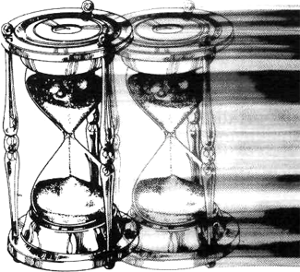

Unit One: The Present Tense

chapter one LITTER IS A PROBLEM IN OUR CITIES
the present tense  PRESENT TENSE OF BE:  I am we are  you are  he, she, it is they are  VERB (+s in third person singular form)  AUXILIARY = do, does for questions and negatives | vocabulary:  litter fence  garbage disease  garbage can punish  ugly jail  spoil litterbug

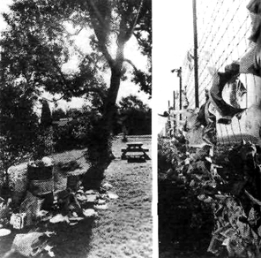
Reading Selection
Listen to the teacher read the selection. Then repeat as the teacher reads in phrases.
Litter is garbage—like food, paper, and cans—on the ground or in the street. Where many people live together, litter is a problem. People don't always put their garbage in the garbage can. It's easier to drop a paper than to find a garbage can for it. But litter is ugly. It makes the city look dirty, and it spoils the view.
The wind blows papers far away. Often they are difficult to catch. When they blow against a fence, they stay there. This fence is a wall of garbage.
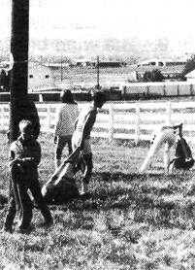
Litter is a health problem, too. Food and garbage bring animals, which sometimes carry disease.
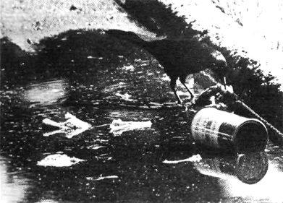
Some people want to control litter. They never throw litter themselves, and sometimes they work together in groups to clean up the city. In most places litter is against the law. The law punishes people who throw garbage on the streets. They usually pay a fine, and occasionally they go to jail.
Two famous sayings in the United States are: “Don't be a litter-bug!” and “Every litter bit hurts!”

Questions
First student: Change each sentence into a question.
Second student: Answer each question with a short answer.
1. Litter is a problem in our cities.
First student: Is litter a problem in our cities?
Second student: Yes, it is.
2. Litter is ugly.
3. Papers are difficult to catch.
4. This fence is a wall of garbage.
5. Litter is against the law.
6. People don't always put their garbage in the garbage cans.
7. Litter makes the city look ugly.
8. Litter spoils the view.
9. The wind blows papers far away.
10. Food and garbage bring animals.
11. Animals sometimes carry disease.
12. Some people want to control litter.
13. They never throw litter themselves. (Don't they ever...)
14. The law punishes litterbugs.
15. They usually pay a fine.

Time Markers
Durative verbs: be, live, want
Punctual verbs: put, drop, bring, carry, throw, work, punish, pay

now
past time present time future time
The present tense shows clearly that in English, tense is not the same as time. The present tense is not usually used to describe present time. Instead, it describes activities and states which are generally and universally true. The present tense is the tense for description, definition, and statements of general truth. As the time line shows, the present tense extends from past time, through the present and into the future. Durative verbs, which show states through time, are verbs like live, want, and be.
Sometimes the present tense is also called the present habitual. It is used for repeated, habitual actions. The X marks on the time line represent punctual verbs, or actions at a specific point in time. These are repeated again and again through time.
Adverbs of frequency are common time markers in the present tense. They tell how often an action is repeated: always, usually, often, sometimes, occasionally, seldom, rarely, hardly ever, never. The word ever is used in questions.
Make a sentence with each frequency adverb below.
1. (not) always—People don't always put their garbage in the garbage can.
2. often
3. sometimes
4. usually
5. occasionally
6. never

Definitions
Match the words on the left with the definitions on the right. Then make complete sentence definitions, using the present tense.
1. litter a. garbage on the ground or in the street
2. fence b. a special can for garbage
3. jail c. everything that a person can see
4. garbage can d. a wall that separates two places
5. view e. sickness
6. fine f. to manage or to stop
7. litterbug g. a number of people
8. disease h. money people pay as punishment
9. control i. a place people stay as punishment
10. group j. a person who throws litter

Pronunciation
The helping verb do is used in the present tense for questions and negatives. However, the vowel letter o is pronounced in three different ways. Look at the pronunciation below.
1. do Used for all subjects except third person singular
do not The vowel is pronounced the same if the two words are not written together in a contraction.
2. don't The vowel changes in the contraction.
3. does The vowel changes again for the third person singular form. Notice that the word is spelled with two vowel letters, but only one vowel sound is pronounced.
doesn't Another vowel sound is pronounced after the s, although it is not written.

Give short answers to the following questions. Use adverbs of frequency in your answers.
1. Do you ever throw litter on the ground?
No, I never do.
Yes, I sometimes do.
2. Do you always throw garbage in the garbage can?
3. Do you usually help to clean up the litter?
4. Does litter always spoil the view?
5. Does the wind often blow papers away?
6. Do litterbugs usually go to jail?
7. Does your friend usually throw litter on the ground?
8. Do animals sometimes carry disease?
9. Do you sometimes help to clean up litter?
10. Does your friend ever help you?

Contractions of the be verb with pronouns and with the word not are very common in spoken English. In some cases, there is a change in the vowel sound in the contracted form. Pronounce the words below.
I, I'm we, we're
you, you're they, they're
he, he's is, isn't
she, she's are, aren't
it, it's
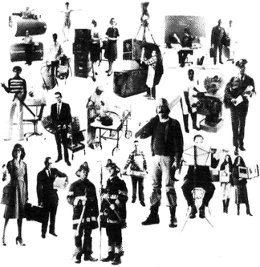 Photos by David Attie

chapter two PEOPLE WORK AT MANY DIFFERENT JOBS
the present tense  PRESENT TENSE OF BE:  I am we are  you are  he, she, it is they are  VERB ( +s in third person singular form)  AUXILIARY = do, does for questions and negatives | (Teaching suggestion: This chapter contains twelve short reading selections. It is best to work with two or three selections in a lesson, until all are completed. Then do the activities at the end of the chapter as a review.)

Reading Selections
Listen to the teacher read the selection. Then repeat as the teacher reads in phrases.
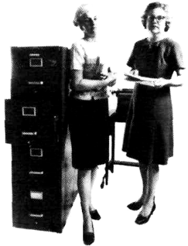
1
vocabulary:
telephone
typewriter
file cabinet
boss

A secretary writes letters, answers the telephone, and meets people. She uses a typewriter every day. She puts papers away in the file cabinet. She stands between her boss and his visitors. She helps her boss to plan his time and to finish his work.

Yes/No Questions
(Use these directions for all the yes/no questions in this chapter.)
First student: Change each sentence into a question.
Second student: Answer each question with a short and a
long answer.
1. A secretary answers the telephone.
First student: Does a secretary answer the telephone?
Second student: Yes, she does. She answers the telephone.
2. A secretary writes books.
First student: Does a secretary write books?
Second student: No, she doesn't. She writes letters.
3. A secretary meets people.
4. She puts papers away in the garbage.
5. She stands between her boss and his visitors.
6. She helps her boss to plan his time.
7. She helps her boss to spoil his work.

Choice Questions
Answer each question with a complete sentence.
1. Does she put papers away in the garbage or in the file cabinet?
She puts papers away in the file cabinet.
2. Does a secretary write books or letters?
3. Does she meet the boss or the visitors?
4. Does she answer the telephone or the typewriter?
5. Does she use the typewriter every day or every week?
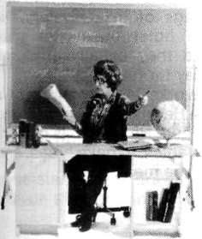
2
vocabulary:

lesson
correct
term
grade

Teachers work in schools. They help their students to learn. They order books, explain lessons, give homework, and correct papers. At the end of every term, they grade their students.

Yes/No Questions
1. Teachers order books and give homework.
2. They explain the lessons to their students.
3. They correct their students' papers.
4. Students grade their teachers.
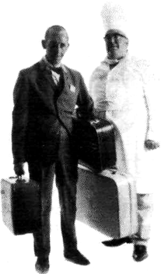
5. Teachers give grades at the beginning of the term.

Choice Questions
1. Does the teacher work in a school or in an office?
2. Does the teacher collect garbage or correct papers?
3. Does the teacher give grades at the beginning or at the end of the term?
3
4
vocabulary:

hotel vegetables
guest bake
restaurant prepare
meal

A porter is a hotel worker who carries the bags of the travelers. He shows the hotel guests to their rooms, and they usually give him some money for his help.
A chef works in a hotel or in a restaurant. He plans the meals and cooks the food. He often has helpers to cut vegetables, to bake bread, and to prepare the meat.

Yes/No Questions
1. A porter works in an office.
2. He helps the guests with their bags.
3. He shows the travelers to their rooms.
4. Hotel guests give the porter letters.
5. Chefs work in hotels.
6. The chef throws away the food.
7. The chef plans the meals.
8. A chef usually has many helpers.

Choice Questions
1. Is the porter a worker or a guest?
2. Does he work in an office or in a hotel?
3. Does he show the travelers their bags or their rooms?
4. Does a chef plan meals or lessons?
5. Does the chef work with other cooks or does he work alone?
6. Do the helpers plan meals or prepare food?
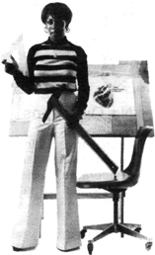
5
vocabulary:

draw
magazine

An artist uses paper, pens, pencils, and paint to make pictures. She draws pictures for books and magazines. Her pictures are easy to understand. The drawings help to explain the ideas in the book.

Yes/No Questions
1. An artist uses pens, pencils, and paint.
2. She draws pictures for books.
3. She writes letters for magazines.
4. Her pictures are hard to understand.
5. Pictures help to explain the ideas in books.

Choice Questions
1. Does an artist use a pen or a typewriter?
2. Does she use her pen to draw or to correct papers?
3. Does the artist order books or make the pictures for books?
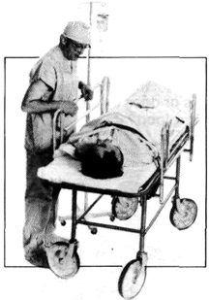
6
vocabulary:

operate medicine
repair patient

One kind of doctor is a surgeon. He works in a hospital. The surgeon operates on sick people; he repairs their bodies. After the operation, he orders medicine. The surgeon watches his patients until they are well.

Yes/No Questions
1. A surgeon is a kind of doctor.
2. The surgeon repairs telephones.
3. He operates on sick people.
4. He watches his patients until they are sick.
5. The surgeon works in a school.

Choice Questions
1. Is the surgeon a doctor or a hotel worker?
2. Does the surgeon order books or medicine for his patients?
3. Are operations for sick people or for well people?
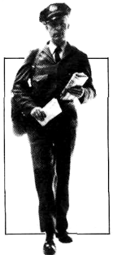
7
vocabulary:

deliver
package
post office

The letter carrier delivers mail. He walks from house to house with letters and packages in his bag. He also picks up letters from the mailboxes and brings them to the post office.

Yes/No Questions
1. The letter carrier brings letters and packages.
2. The letter carrier works in a restaurant.
3. He picks up letters from mailboxes.
4. He walks from house to house.
5. The letter carrier brings letters to the post office.

Choice Questions
1. Is the letter carrier a hospital worker or a post office worker?
2. Does he pick up letters or visitors?
3. Does he carry a mailbag or a mailbox?
4. Does he write letters or deliver them?
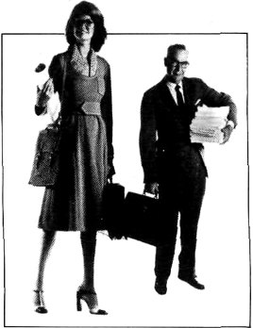
8
vocabulary:

activity
hire

A businessperson works in an office. He plans business activities. He prepares reports and goes to meetings. He learns about buying, selling, and producing things. A businessperson must hire workers to help him.

Yes/No Questions
1. A businessperson works with patients.
2. An office is a place of business.
3. A businessperson goes to business meetings.
4. Buying and selling are business activities.
5. A businessperson hires other workers.

Choice Questions
1. Does a businessperson prepare meals or reports?
2. Does he work in an office or in a school?
3. Does he work together with other people or alone?
9
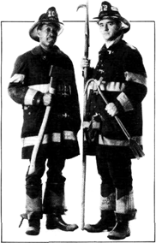
vocabulary:

prevent
inspect
fire engine
put out

A firefighter tries to prevent fires by inspecting buildings. He asks people to make their houses safe from fire. When a fire starts, he rides to the building in a fire engine. Firefighters hurry to put out fires and to save people.

Yes/No Questions
1. A firefighter works in a post office.
2. He tries to prevent fires.
3. He asks people to throw litter.
4. Firefighters ride to fires in fire engines,
5. They save people from fires.

Choice Questions
1. Does a firefighter start fires or put them out?
2. Does a firefighter inspect buildings or food?
3. Do firefighters save people or money?

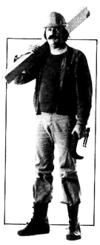
10
vocabulary:

brick
metal
apartment

A construction worker puts buildings together. He measures wood and cuts it into pieces. He carries bricks and metal parts. He follows a building plan to make houses, apartments, and stores. Sometimes he repairs buildings, too.

Yes/No Questions
1. A construction worker puts apartments together.
2. He measures and cuts bricks.
3. He carries bricks and metal parts.
4. He follows a lesson plan.
5. Construction workers build houses and stores.

Choice Questions
1. Does a construction worker put together buildings or telephones?
2. Does he cut wood or bricks?
3. Does he repair buildings or people?

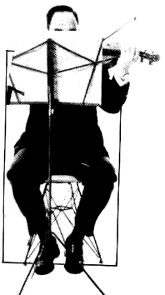
11
vocabulary:

orchestra
practice
instrument

A musician usually works with other musicians to make music. Musicians play together in an orchestra. They practice playing their instruments every day. They read new music and play it until it sounds good.

Yes/No Questions
1. An orchestra is a group of musicians.
2. Musicians make instruments.
3. A musician has to practice every day.
4. Musicians read music.
5. New music always sounds good.

Choice Questions
1. Does a musician make instruments or music?
2. Do musicians practice every week or every day?
3. Do musicians play in an orchestra or in a post office?

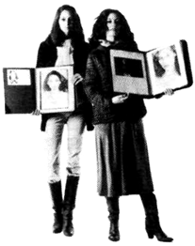
12
vocabulary:

fashion
style
camera
newspaper

Fashion models show us the newest styles of clothes. They put on new clothes and stand in front of cameras. Pictures of models appear in newspapers and in magazines. People see the pictures and want to buy the clothes. Fashion models collect pictures of themselves in a book.

Yes/No Questions
1. Fashion models show us new styles of cameras.
2. They stand in front of cameras.
3. Their pictures appear in newspapers and magazines.
4. Fashion models collect business reports.
5. Fashion models help sell new fashions.

Choice Questions
1. Do fashion models put on new clothes or old clothes?
2. Do models help sell books or clothes?
3. Do they collect pictures or magazines?

Time Markers
Durative Verbs: have, be

Punctual Verbs: carry, cut, explain, give, help, order, plan,
practice, prepare, repair, show, use, work
Sometimes the present tense is called the present habitual tense because it is used to describe habitual, repeated actions. The reading selections in this chapter, which are about workers and their jobs, contain many examples of habitual activities. Common time markers are the combinations with every (every day, every week, every month, every term, every meal, every time ...).

Who- Questions
Answer the following questions by giving the kind of worker who does each activity. Then make ten who- questions of your own to ask the other students.
1. Who puts out fires?
2. Who draws pictures for books and magazines?
3. Who carries the travelers' bags?
4. Who plans business activities?
5. Who builds and repairs houses?
6. Who operates on sick people?
7. Who helps her boss to plan his time?
8. Who grades students at the end of every term?
9. Who makes music in an orchestra?
10. Who operates on sick people?
11. Who brings letters and packages from house to house?
12. Who shows us the newest styles of clothes?

A Guessing Game
Choose a student to be the leader. The leader should think o! one of the workers in this chapter, but he should not tell which worker it is. The other students will take turns guessing what the worker does. The student who guesses correctly may then start the game again.
Example: First student I'm thinking of a worker.
Second student Does he operate on sick people?
First student No, he doesn't.
Third student Does he put buildings together?
First student No, he doesn't.
Fourth student Does he carry letters?
First student Yes, he does.
Fourth student Is he the letter carrier?
First student Yes, he is.

Pronunciation
Third person singular -s ending
In the present tense, when the subject is he, she, or it, the verb takes an -s ending. After verbs which end in voiced sounds, the -s is pronounced like /z/. Pronounce the words below.
answers gives rides
brings goes sells
buys plans shows
carries plays sounds

chapter three HANDICAPPED PEOPLE DO USEFUL WORK
the present tense  PRESENT TENSE OF BE:  I am we are  you are  he, she, it is they are  VERB (+ s in third person singular form)  AUXILIARY = do, does for question and negatives | vocabulary:  blind  handicapped  earn  broom  mop

Reading Selection
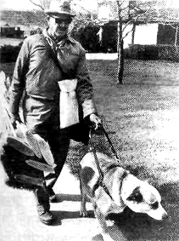
Listen to the teacher read the selection. Then repeat as the teacher reads in phrases.
Joseph Emmons can't use his eyes. He's blind. He has a trained dog named Buster that leads him where he wants to go. Buster sees for Mr. Emmons. He's called a seeing-eye dog.
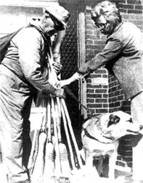
Although Mr. Emmons has a handicap, it isn't a big problem. He has a useful job and he earns his own money. Mr. Emmons sells brooms and mops to people in this part of the city. He has worked every day except Sunday for forty years.
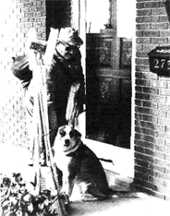
Mr. Emmons gets up at 6:00 every morning and eats breakfast with his wife. Then he leaves the house at 7:00. He holds Buster and walks from house to house. He carries his mops and brooms with him. While he talks to people, the dog sits and waits. The people choose a broom, and then they pay him.
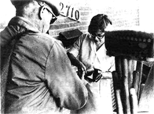
Buster doesn't let Mr. Emmons talk to people very long. He likes to keep moving. It takes four and one-half months to walk to every house in this part of the city, Mr. Emmons visits each house every four months, and by then the people are usually ready to buy new brooms.
Mr. Emmons likes his job. He's very healthy because he works outside every day. But these days he has a problem. His brooms last so long that sometimes they are still good after four months. Then nobody needsi buy a new one.
Mr. Emmons is proud of brooms because blind people make them. He picks up a new supply of brooms every week. He says, “If you don't sell people something good they're not going to buy from you this second time you come around.”

Questions
Answer each question with a sentence from the story.
1. Why can't Joseph Emmons use his eyes?
2. Why is Buster called a “seeing-eye dog”?
3. Why isn't Mr. Emmons' handicap a big problem?
4. Why doesn't Buster let Mr. Emmons talk very long?
5. Why do the people usually buy new brooms every time that Mr. Emmons comes?
6. Why does Mr. Emmons like his job?
7. Why is he so healthy?
8. Why does Mr, Emmons have a problem selling brooms?
9. Why is he proud of his brooms?
10. Why should you sell people something good?

Time Markers
Durative Verbs: be, have, like

Punctual Verbs: eat, get up, sell,
buy, pay, choose, visit, pick up
The present habitual tense is often used to describe daily routines or regular activities. Time markers like every day, every week, and every month show repeated action.
Answer each question about Mr. Emmons' daily routine.
1. How often does Mr. Emmons work?
2. How often does Buster work?
3. What time does Mr. Emmons get up every day?
4. What does he do next?
5. What time does he leave the house every day?
6. How often does Mr. Emmons visit each house?
7. How often do most people buy brooms?
8. How often does he get a new supply of brooms?

An Interview with Mr. Emmons
Choose a partner to work with you on the interview below. Pretend that you are a newspaper reporter and you are talking to Mr. Emmons. Ask questions which would produce the answers below.
Reporter:
Mr. Emmons: No, my blindness is not a new problem. I've been blind since I was a child.
Reporter:
Mr. Emmons: I earn money by selling mops and brooms.
Reporter:
Mr. Emmons: In this part of the city.
Reporter:
Mr. Emmons: My dog Buster leads me where I want to go.
Reporter:
Mr. Emmons: Every day except Sunday.
Reporter:
Mr. Emmons: Every four months.
Reporter:
Mr. Emmons: People like my brooms because they last so long.
Reporter:
Mr. Emmons: Blind people do.
Reporter:
Mr. Emmons: Yes, I like my job very much.
Reporter:
Mr. Emmons: It keeps me busy and I can stay outside most of the time.

Pronunciation
Third person singular -s ending
After verbs which end in voiceless sounds, such as /f/, /k/, /p/ and /t/, the third person singular -s is pronounced like Is/. Pronounce the words below.
helps meets waits
keeps sits walks
likes takes wants
makes talks works

chapter four HALLOWE'EN IS A HOLIDAY FOR CHILDREN
the present tense  PRESENT TENSE OF BE:  I am we are  you are  he, she, it is they are  VERB (+ s in third person singular form)  AUXILIARY = do, does (for questions and negatives) | vocabulary:  autumn mask  holiday frightening  celebrate costume  holy monster  All-Saints Day trick  orange treat  pumpkin adult  jack-o'-lantern candy  lantern UNICEF

Reading Selection
Listen to the teacher read the selection. Then repeat as the teacher reads in phrases.
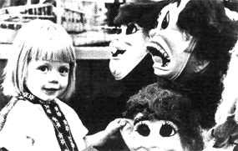
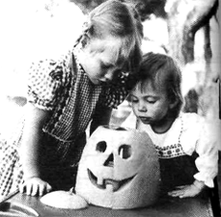
Hallowe'en is an autumn holiday that Americans celebrate every year. It means “holy evening,” and it comes every October 31, the evening before All-Saints Day. However, it's not really a church holiday; it's a holiday for children.
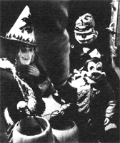
Every autumn, when the vegetables are ready to eat, children pick large orange pumpkins. Then they cut faces in the pumpkins and put lights inside. It looks like there is a person looking out of the pumpkin! These lights are called jack-o'-lanterns, which means “Jack of the lantern.”
The children also put on strange masks and frightening costumes every Hallowe'en. Some children paint their faces to look like monsters. Then they carry boxes or bags from house to house. Every time they come to a new house, they say,
“Trick or treat! Money or eat!” The adults put a treat—money or candy—in their bags.
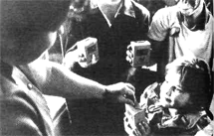
Some children think of other people on Hallowe'en. They carry boxes for UNICEF (The United Nations International Children's Emergency Fund). They ask for money to help poor children all around the world. Of course, every time they help UNICEF, they usually receive a treat for themselves, too.

Questions
Make a question with the information and the question word given in each number below.
1. Hallowe'en means “holy evening.” (What)
What does Hallowe'en mean?
2. It's not really a church holiday; it's a holiday for children. (What kind of)
3. Children pick farge orange pumpkins. (What)
4. They cut faces in the pumpkins and put lights inside. (What)
5. They carry boxes or bags from house to house. (What)
7. Some children think of other people on Hallowe'en. (Who)
8. They ask for money to help poor children all around the world. (Why)

Time Markers
Durative Verbs: be, mean

Punctual Verbs: celebrate, come, pick, cut,
put on, paint, ask, help, receive
Below are the answers to some questions, but the questions have been left out. Make a question to go with each answer.
1. Every year.
(How often do Americans celebrate Hallowe'en?)
2. Every October 31.
3. Every November 1.
4. Every autumn, when the vegetables are ready to eat.
5. Every Hallowe'en.
6. Every time they come to a new house.
7. Every time the children come to the door.
8. Every time they help UNICEF.

Definitions
Match the words on the left with the definitions on the right. Then make complete sentence definitions, using the present tense.
1. jack-o'-lantern a. the season which comes after summer and before winter
2. pumpkin b. an autumn holiday for children
3. monster c. a religious holiday that people celebrate on November 1
4. treat d. a large, round, orange vegetable
5. autumn e. a pumpkin with a face cut in it
6. Hallowe'en f. a false face
7. All-Saints Day g. an unusual, frightening creature
8. mask h. a gift such as money or candy
9. adult i. a United Nations group which helps poor children around the world
10. UNICEF j. a person who is grown up

Pronunciation
Third person singular -s ending
After verbs which end in sibilants, such as /s/,/z/,/š/,/ž/,/č/,/ǰ/, an extra vowel is added and the third person singular-s is pronounced like /ə/. Pronounce the words below.
catches produces
chooses punishes
finishes uses
practices watches

Unit Two: The Present Continuous Tense

chapter five THE KITES ARE FLYING HIGH
the present continuous tense  BE + VERB + ing | vocabulary:  kite  string  climb

Reading Selection
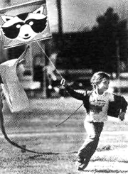
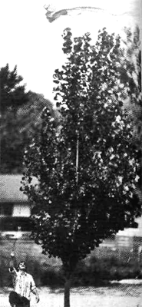
Listen to the teacher read the selection. Then repeat as the teacher reads in phrases.

This girl is holding a kite. She's running as fast as she can, and the kite is rising into the air. While running, she's letting out string. The kite is rising higher and higher. Occasionally, small children let go of their kites, and then the kites fly out of view.

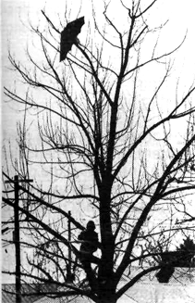
The second kite is flying over a tree. When the wind blows hard, it's more difficult to fly kites. This father is helping his little girl, and he's having a very good time. Happy families often play together.

This man is having a little trouble with a “kite-eating tree.” He's climbing the tree to get his kite down. Sometimes kites break when they get caught in trees.
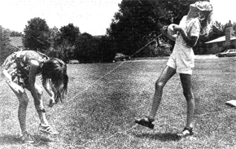
These girls are trying to fly kites, too. They're having fun, but one of them is getting caught in the string. The other girl is laughing too hard to help her friend. This kind of trouble seldom spoils anybody's fun, but it often breaks the kite string.

Questions
1. What is the girl in the first picture holding?
2. How is she running?
3. Where is the kite going?
4. What is she doing while she is running?
5. Where is the second kite flying?
6. Who is holding the string?
7. Why is the father helping his little girl?
8. When is it more difficult to fly a kite, on a still day or on a windy day?
9. What is the problem in the third picture?
10. Why is the man climbing the tree?
11. What are the two girls in the fourth picture trying to do?
12. Why are they laughing?

Time Markers

holding, running, rising, flying
climbing, helping, trying, laughing

The present continuous tense describes present time. It is used for actions which are happening in the present, and for a period of time which includes the present. On the time line above, the circle represents this period of time. In the present continuous tense, time markers are not always used. English speakers understand the tense itself to mean “right now” or “a period of time including right now”. Some other time markers for present time are combinations with this (this week, this month, this term, this year), these (these days), and also today and tonight.
Repeat each sentence after your teacher. Then use a different time marker and change the tense to agree with it.
1. She sometimes flies a kite. (today)
She's flying a kite today.
2. Occasionally, small children let go of their kites. (now)
3. The kites often fly out of view. (at this moment)
4. The wind blows hard in the spring. (this morning)
5. The father usually helps his little girl. (now)
6. We fly kites when we want to. (this week)
7. They seldom have trouble with their kites. (these days)
8. You sometimes laugh too hard to help me. (now)

Listening Discrimination
The chapter reading contains five sentences that are not in the present continuous tense. These five sentences are statements of general truth or repeated action; their meaning is not “right now”. They are in the present tense, and they contain these time markers: occasionally, often, sometimes, seldom, when the wind blows hard.

Listen as your teacher reads the paragraphs again. Raise your hand each time you hear a sentence that is not in the present continuous tense.

Contrasting Tenses
Statements of general truth
Statements of present activity

Something that is true in general may or may not be true at the present moment. Contrast the present and the present continuous tenses in each sentence below. Use the time marker now with the present continuous.
1. Occasionally, small children let go of their kites, but ...
Occasionally, small children let go of their kites, but she is not letting go of her kite now.
2. Occasionally, kites fly out of view, but ...
3. When the wind blows hard, it's difficult to fly kites, but ...
4. Happy families often play together, and ...
5. Sometimes kites break when they get caught in trees, but ...
6. This kind of trouble seldom spoils anybody's fun, but ...

Pronunciation
People who are learning English sometimes say that they cannot hear the verb be (am, is, are) when English speakers are using the present continuous tense. This is partly because the be verb is not stressed, and it is not given much time in normal speech. Often it seems to run into the word before it or the word after it. The following forms are not formal contractions; they may not be written as contractions in English, but they sound like contractions. They are called reduced forms. Pronounce the following sentences.
1. This girl is holding a kite.
2. The kite is rising into the air.
3. This father is helping his little girl.
4. This man is having a little trouble.
5. These girls are trying to fly kites, too.
6. One of them is getting caught in the string.
7. The other girl is laughing too hard to help her friend.
8. What is the girl holding?
9. How is she running?
10. Where is the kite going?
11. Who is holding the string?
12. Why is the man climbing the tree?
13. When is it difficult to fly a kite?
14. What are the girls trying to do?
15. Why are they laughing?

chapter six
POLLUTION IS SPOILING THE AIR YOU BREATHE!
the present tense used for  activities in the present  VERBS OF MENTAL ACTIVITY OR MENTAL STATE  VERBS OF CONDITION | vocabulary:  pollution breathe  dirt harm  dirty lungs  pour gas  factory mask

Reading Selection
Listen to the teacher read the selection. Then repeat as the teacher reads in phrases.

Pollution is hanging like a brown cloud over New York today. Dirt and smoke are pouring from cars and factories. Pollution is spoiling the air we breathe, and it's harming our health.
New York has a big problem these days. The city has dirty air. The airsmells bad, and it looks ugly. Pollution is a health problem, too, because it's hurting people's lungs.

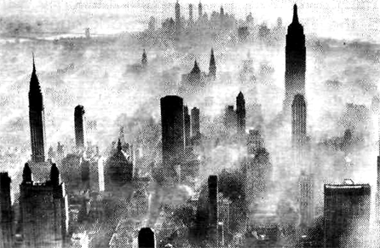
Source Aero Service Division of Litton Industries
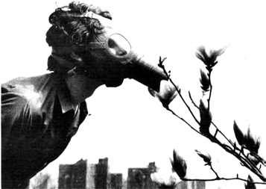
This man thinks that pollution is dangerous. He doesn't like the air, so he isn't breathing it. He's wearing a gas mask. He's smelling a flower, and it smells good, but he doesn't know it. He's touching the flower with his mask, and the flower feels soft, but he doesn't know it.
He's listening for birds, but he doesn't hear any. He's looking for beauty, but he doesn't see any. He believes that pollution is coming between us and the beauty of nature. He's trying to show his ideas with the gas mask. He wants people to work together now and to make the air cleaner soon.

Questions
1. What is hanging like a brown cloud over New York today?
2. Where are the dirt and smoke coming from?
3. What is pollution doing to our air and to our health?
4. What problem does New York have?
5. How does the air smell and look?
6. Why is pollution a health problem?
7. Why is the man wearing a gas mask?
8. Why doesn't he like the air?
9. What does he think about pollution?
10. What is he trying to do?

Time Markers
The time for both these pictures is present time: today, these days. We expect the tense to be present continuous, and for many of the sentences, it is. However, some of the sentences have been written in the present tense, eMen though thev are not definitions or statements of general truth.
In English, a certain group of verbs cannot take any continuous tense. These are verbs which describe mental states or mental activity or conditions of things. Therefore, to show present time, these verbs take the present tense instead.

think, see, understand, have, be, feel

Verbs of Mental Activity or Mental State Which Do
Not Take Continuous Tenses

believe
hate
have (meaning to own; some exceptions are idioms with have. These idioms are used in continuous tenses: to have fun, to have a party, to have a good time, to have a bad time, to have trouble)
hear
know
like
love
need
own
see
think (meaning to believe. Think about has a different meaning and can take continuous tenses.)
understand
want

Verbs of Condition Which Do Not Take Continuous Tenses
appear (meaning to seem)
be
*feel (when used with no object)
look (meaning to appear)
seem
*smell (when used with no object)
sound
*taste (when used with no object)

*When these verbs are used with objects, they have a different meaning. With objects, they are active verbs and can take continuous tenses. Contrast these sentences:
The man is feeling the flower. It feels soft.
He is smelling the flower. It smells good.
She is tasting the water. It tastes fresh.

Contrasting Tenses
The following questions all refer to present time. Notice whether they are in the present or the present continuous tense. Answer each question with both a short and a long answer.

1. Is he breathing the air?
No, he isn't. He isn't breathing the air.
2. Does he like the air?
No, he doesn't. He doesn't like the air.
3. Is he smelling the air?
4. Does the air smell bad?
5. Is he thinking about pollution?
6. Does he think pollution is dangerous?
7. Is he looking at the smoke?
8. Does the smoke look beautiful?
9. Is he having trouble breathing?
10. Does he have a gas mask?
11. Is he smelling the flower?
12. Does the flower smell good?
13. Is he touching the flower with his mask?
14. Does the flower feel soft?
15. Is he listening for birds?
16. Does he hear any birds?
17. Is he looking for beauty?
18. Does he see any beauty?

Choosing Tenses
Make a sentence with each group of words. Use either the present or the present continuous tense.
1. I / think about / litter
2. I / think / litter is ugly
3. The children / have / kites
4. The children / have / a good time
5. The fashion model / look at / new clothes
6. New clothes / look / beautiful
7. Blind man / look for / dog
8. Blind man / see / dog
9. Musician / listen to/ instrument
10. Musician / hear/ instrument
11. Cars / sound / loud
12. Surgeon / feel / patient's face
13. Patient / feel / hot
14. Chef/ smell / meal
15. Food / smell / ready to eat

Pronunciation
The -ing verb ending
In normal spoken English, the -ing ending is not stressed. In addition, the final /n/ sound often carries into the next word if the next word begins with a vowel. Practice the sentences below. Place the stress on the marked syllables, and pronounce the verb ending as /ən/.
1. The girl is holding a kite.
2. The kite is rising into the air.
3. This father is helping his little girl.
4. This man is having a little trouble.
5. These girls are trying to fly kites.
6. The other girl is laughing.

Unit Three: The Present Perfect Tenses

chapter seven THIS WOMAN HAS LOST HER JOB
vocabulary:

sweater
remove
tag
private secretary
the present perfect tense upset
HAVE (or HAS) + PAST PARTICIPLE worried

Reading Selection
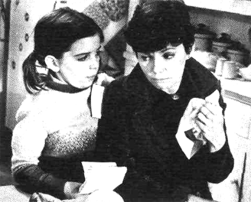
Listen to the teacher read the selection. Then repeat as the teacher reads in phrases.

Mrs. Clark and her daughter Sarah have been out shopping, and they've just returned home. They bought Sarah a new sweater, and she's already put it on. It's so new that they haven't even removed the tag yet.
Mrs. Clark has just opened a letter, and she's received bad news. She's lost her job! For the past year she's worked as a private secretary for a rich musician. Now the musician has decided to stop working, and he's asked Mrs. Clark to find another job. Mrs. Clark is the only money earner in the family, since her husband is no longer living.

Source: Warner Brothers
The letter has upset Mrs. Clark very much. She's crying. She's recently bought a new house, a new car, and many new clothes for her job. She hasn't paid for them yet. Now she may not be able to pay for them, because she hasn't saved much money.
Sarah has heard the bad news, but she really doesn't understand much about money. She's more worried about her mother. Mrs. Clark has never cried in front of her daughter before.

Yes/No Questions
First student: Change each sentence into a question.
Second student: Answer each question with a short answer.
1. Mrs. Clark and Sarah have been out shopping.
First student: Have Mrs. Clark and Sarah been out shopping?
Second student: Yes, they have.
2. They've just returned home.
3. Mrs. Clark has just opened a letter.
4. She has worked as a private secretary for a musician.
5. The musician has stopped working.
6. He has asked her to find another job.
7. The letter has upset Mrs. Clark.
8. She has not paid for her new house yet.
9. Sarah has heard the bad news.
10. Mrs. Clark has never cried in front of Sarah before.

Choice Questions
Answer with a complete sentence.
1. Have they bought Sarah a sweater or a coat?
2. Has she put the sweater on or has she put it away?
3. Has Mrs. Clark received good news or bad news?
4. Has she lost her house or her job?
5. Has she bought a few things or a lot of things?
6. Has she saved a lot of money or a little money?

Time Markers

Punctual verbs: has asked, has bought, has decided, has heard,
has lost, has opened, has put on, has returned

One meaning of the present perfect tense is that an action has been completed before the present time. This action has an effect on the present situation, but it is not happening in the present. The verbs above describe completed actions which took place at one point in time. Durative verbs are not often used for this meaning of the present perfect tense. What is important here is not how long the activity lasted, but that it is finished. In this time line, the X is especially dark to represent the fact that the action is completed. Common time markers are: already, not yet, and just.

Answer the questions below in the present perfect tense. Use a time marker in each sentence.
1. Are Mrs. Clark and Sarah returning home now? (just)
No, they've just returned home.
2. Is Sarah putting on her sweater now? (just)
3. Is Sarah removing the tag now? (not yet)
4. Is Mrs. Clark opening the letter now? (just)
5. Is Mrs. Clark receiving bad news now? (just)
6. Is she losing her job now? (already)
7. Is the musician deciding now to stop work? (already)
8. Is he asking her now to find another job? (already)
9. Is she buying a house now? (already)
10. Is she paying for the house now? (not yet)

Listening Discrimination
Listen to the sentences as your teacher reads them. If the sentence is in the present continuous, respond with the time marker “now.” If the sentence is in the present perfect, respond with the time marker “already.”
1. He's returning home.
2. She's buying a new house.
3. She's bought some new clothes.
4. She's putting them on.
5. He's opened the letter.
6. He's removing the tag.
7. He's asked his secretary.
8. He's decided about his job.
9. She's paid for everything.
10. She's crying about her job.

Time Lines
Make sentences with the verbs below. Use the tense which is indicated in each time line.
1. 2.
have returned bought
3. 4.
( )

has put it on haven't removed
5. 6.
has asked is crying
7. 8.
( )

has not paid doesn't understand
9. 10.
( )

has heard has never cried

Pronunciation
In normal spoken English, pronouns contract with the auxiliary verbs has and have in the present perfect tense. He's /hɪz/, she's /ʃɪz/, and it's /ɪts/ sound just like the contractions for he + is, she + is, and it + is. Practice the sentences below.
1. I've been out shopping.
2. You've returned home.
3. He's bought a new sweater.
4. She's opened a letter.
5. It's upset her a lot.
6. We've received bad news.
7. They've lost their money.
Other subjects may combine with has and have in spoken English, too. These are reduced forms. They are not written as contractions, but are pronounced that way.
1. Mrs. Clark has received bad news.
2. Sarah has removed the tag from the sweater.
3. The musician has decided to stop working.
4. The secretary has worked for a year.
5. The letter has upset her a lot.
6. The news has always been bad.
7. The house has cost a lot of money.
8. The clothes have come from the store.

chapter eight IT'S DIFFICULT TO SAY GOOD-BYE
The present perfect tense

HAVE (or HAS) + PAST PARTICIPLE

vocabulary:

journalism
reporter

Reading Selection
Listen to the teacher read the selection. Then repeat as the teacher reads in phrases.
People often travel to other places to study or to work. Ralph is going to get on the train and travel to a new job. He's saying good-bye to his girl friend Stella and her brother Tom.
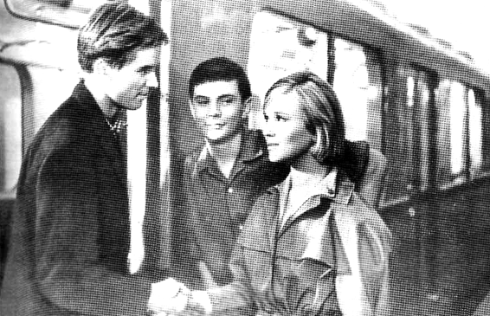
The three friends have known each other for many years. They've been neighbors since they were children. Ralph has lived next door to Stella and Tom for fifteen years. They've grown up together, they've gone to school together, and they've visited each other almost every day.
Stella and Ralph have been an important part of each other's lives, so it's difficult to say good-bye. They've studied journalism together, and they've worked as reporters for a small town newspaper. Now Ralph has a job working for a big city newspaper 500 kilometers away. Ralph and Stella will miss each other very much, but Ralph will come home again on his vacations.

Questions
1. Who is going to travel on the train?
2. Who is saying good-bye to Ralph?
3. How long have they all known each other?
4. Where has Ralph lived for fifteen years?
5. Who has grown up with Ralph?
6. Where have they gone every day?
7. How often have they visited each other?
8. Where have Ralph and Stella worked?
9. Where is Ralph going to work now?
10. Why is it difficult for them to say good-bye?
11. How will Stella feel when Ralph is gone?
12. When will Ralph come home?

Time Markers

Durative verbs: has been, has lived, has known,
has studied, has worked

One job of the present perfect tense is to show an activity or a state that has continued for a period of time, from a point in the past until the present. (Notice two things about this meaning that are different from the meaning of the tense in the last chapter. With the time picture above, the action is not completed; it is still continuing in the present. Second, it is the length of time that is important.) In these time lines, the arrow part of the picture is dark. This is to emphasize the length of time that the activity has continued. Durative verbs are common in this meaning of the present perfect tense. Time markers for this idea are: for (for many years) and since (since they were children).

Punctual verbs: has visited, has seen, has gone, has talked
If a punctual verb is used this way, we know that the action was repeated many times for a period of time. For example, “They have visited each other every day for fifteen years.” In this sentence, there are two time markers. One shows the frequency (every day) and the second shows the duration (for fifteen years).
Make sentences out of the groups of words below. Each sentence should be in the present perfect tense and should show an activity or a state which began in the past and has continued to the present.
1. know / for many years
2. be friends / since 1965
3. be neighbors / for fifteen years
4. live next door to her / since 1965
5. go to school / every day / for twelve years
6. visit her / every day / for two years
7. study journalism / since 1975
8. work as a reporter / for three years
9. be important to her / for a long time
10. love her / since I met her

Contrasting Completed Action and Duration
Listen to the sentences as your teacher reads them. If the sentence shows completed action, respond with the time marker “already.” If the sentence shows duration, respond with the time marker “for many years.”
1. Ralph has met Stella.
2. Ralph has known Stella.
3. Ralph has moved next door to Stella.
4. Ralph has lived next door to Stella.
5. Ralph has gone to school today.
6. Ralph has gone to school every day.
7. Ralph has worked in journalism.
8. Ralph has lost his job.
9. Ralph has taken another job.
10. Ralph has loved Stella.
11. Ralph has visited Stella every day.
12. Ralph has said good-bye to Stella.

Changing Times, Changing Tenses
Repeat each sentence after your teacher. Then use a different time marker and change the tense to agree with it.
1. Ralph is visiting Stella now. (every week - already)
Ralph visits Stella every week.
Ralph has visited Stella already.
2. They go to school together every morning. (this morning - for many years)
3. Ralph has studied journalism for two years. (these days - every evening)
4. Ralph isn't coming home to visit this month. (every month - yet)
5. He often travels to London. (now - every month for a year)
6. He isn't taking the train. (usually - yet)
7. They're working together on the newspaper today. (every day for six months - seldom)
8. She isn't writing him a letter now. (often - for three weeks)
9. His boss doesn't hire any new reporters in the summer. (this summer - for a year)
10. Stella works for the small newspaper occasionally. (these days - for a long time)

Pronunciation
In normal spoken English, the question words usually combine with the auxiliary verbs has and have. These are reduced forms. They are not written as contractions, but they are pronounced that way.
1. How long have they known each other?
2. Where has Ralph lived for fifteen years?
3. Who has grown up with Ralph?
4. Where have they gone every day?
5. How often have they visited each other?
6. What have Ralph and Stella studied?

Listening Discrimination
Listen to the sentences as your teacher reads them. If the sentence is in the present continuous, respond with the time marker “now.” If the sentence is in the present perfect, respond with the time marker “already.”
1. Who's gone to the big city?
2. Who's traveling on the train?
3. Who's saying hello to new friends?
4. Who's grown up to be a journalist?
5. Who's visited his sick friend?
6. Who's studying medicine?
7. Who's working on the newspaper?
8. Who's come home?

chapter nine ARE BUSES AS EASY TO USE AS CARS?

vocabulary:

traffic decrease
complain schedule
smart convenient
parking place
the present perfect continuous tense
HAVE (or HAS) + BEEN + VERB + ing

Reading Selection
Listen to the teacher read the selection. Then repeat as the teacher reads in phrases.
When the weather is cold, it's not very much fun to wait for a bus. These people have been standing on the corner for fifteen minutes. They've been watching the traffic, looking for the bus, and hoping it will come soon. They've been talking about the bus and complaining about the weather. Most of them feel cold. One smart man has been drinking coffee to stay warm.
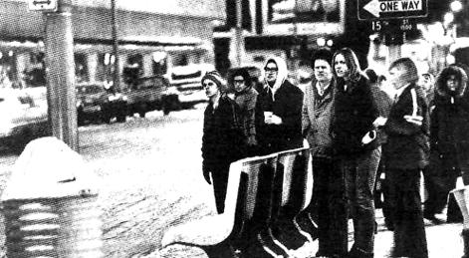
Traveling on buses decreases pollution, but people often would rather drive their cars. Many people aren't used to the bus schedules, and they don't like to wait.
On the other hand, many people have been taking the bus every day for many years. They're used to it. They say the bus has been coming on time every day, and they've never been late to work. In addition, they haven't needed a parking place in all that time. Buses are very convenient when you're used to them.

Questions
1. How long have the people been standing on the corner?
2. What have they been doing? (Give five answers.)
3. Why has one man been drinking coffee?
4. What are some good reasons for taking buses?
5. What are some reasons for driving cars?
6. What are some problems with buses?
7. What are some problems with cars?

Time Markers
Durative verbs: have been standing, have been watching, have been hoping | Punctual verbs: have been taking (the bus), have been coming
The present perfect continuous tense has the same time line as the durative part of the present perfect tense, which was in the last chapter. Like the present perfect (durative), the present perfect continuous is used for activities or states that began in the past and have continued to the present. The activity or state has not stopped at the present time; it is still happening.
Durative verbs, which express one long continuous activity, are: stand, watch, look for, hope, talk, complain, drink, and wait. Time markers show the length of time of the activity: for (fifteen minutes) and since.
Punctual verbs can also be used in the present perfect continuous tense: take (the bus) and come. Punctual verbs give the idea of repeated actions through a period of time. Time markers show the frequency of the activity; every day, never, and every day for many years.
Of course, some verbs can never take a continuous tense. (For a review of these verbs, see chapter six.) Noncontinuous verbs take the present perfect tense, and indicate an activity or a state over a period of time. For example: They have not needed a parking place in all that time.

Action Completed and Activity Overa Period of Time
The present perfect continuous tense is not used to describe completed action; for that time picture, we use the present perfect. Listen to the sentences below as your teacher reads them. All are in the present perfect tense. Some of the verbs describe a period of time, and some describe a completed action. If the verb describes an activity over a period of time, change it to the present perfect continuous tense. If it describes a completed action, simply repeat the sentence as it is.
1. He's bought a ticket already.
2. He's taken the bus for one month.
3. He's stood on the corner since 9 a.m.
4. He's asked the bus driver for a ticket.
5. We've caught the bus on the corner every day this week.
6. The bus has come on time every day.
7. We've waited for almost an hour.
8. He's drunk all his coffee already.

Noncontinuous Verbs
Listen to the sentences as the teacher reads them. If you can, change the verb phrase to the present perfect continuous tense. If the verb cannot take a continuous tense, simply repeat the sentence as it is.
1. I've owned a car for ten years.
2. I've driven it to work every day.
3. I've never believed that cars are dirty.
4. I've always thought that cars are convenient.
5. I've taken my car to the center of the city.
6. I've parked very close to my office.
7. It's taken half an hour to drive to work.
8. I've always hated to wait in the cold.
9. I've thought about taking the bus in the summer.
10. I've waited for a more convenient bus schedule.
11. I haven't ever had a car.
12. I've taken the bus every day for years.
13. I've had a lot of fun riding buses.
14. The schedule has been convenient for me.
15. The bus has come on time every day.
16. I've always liked the buses.
17. I've ridden with the same bus driver for two years.
18. I've said hello to him every morning.
19. The air has seemed polluted this week.
20. The weather has felt cold all week.

Role Playing
In the exercise above, sentences 1-10 present the point of view of a person who drives a car regularly. Sentences 11-20 express the view of a person who usually rides the bus.
Choose a partner and make up a conversation between a car driver and a bus rider. You may use ideas and sentences from the previous exercise. The people in your conversation will probably agree about some things and disagree about others. Perform your conversation for the class.

Time Lines
Make sentences with the verbs below. Use the tense which is indicated in each time line.
1. 2.
have been standing have been watching
3. 4.
have been hoping feel cold
5. 6.
have been drinking decreases pollution
7. 8.
have been taking have been coming
9. 10.
have not needed are convenient

Changing Times, Changing Tenses
Retell the story in chapter eight, “It's Difficult to Say Good-bye.” Use the present perfect continuous tense wherever it is possible.

Unit Four: The Past Tense

chapter ten LIGHTNING STRUCK THE CITY LAST NIGHT
the past tense  PAST TENSE OF BE:  I was we were  you were  he, she, it was they were  VERB ( + ed)  AUXILIARY = did (for questions and negatives) | vocabulary:  lightning chimney  struck rod  twice bark  flash lucky

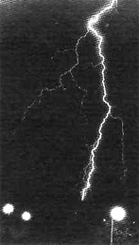
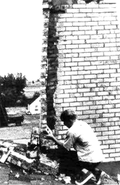
Reading Selection
Listen to the teacher read the selection. Then repeat as the teacher reads in phrases.
Lightning struck twice by our house last night during a rainstorm. One flash of lightning hit at 9:10, and the second hit at 9:20. We heard the sound of thunder and we smelted the lightning in the air.
The first flash struck our neighbor's chimney. The chimney was very tall, and it acted like a lightning rod.
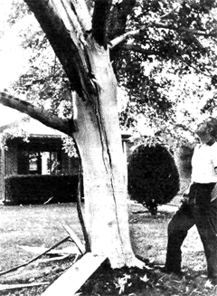
It pulled the lightning to it. When the lightning struck, it tore out a whole row of bricks. Our neighbors said it sounded like glass was breaking when the bricks fell.
The second flash hit another neighbor's tree. It tore the bark off the tree. Because it was raining, the tree didn't start to burn. However, our neighbor said that the lightning killed the tree.
We were lucky. The lightning missed our house. And we were all happy that nobody was hurt.

Questions
1. Did lightning strike once or twice last night?
2. Did they hear the thunder or the lightning?
3. Did they smell fire or lightning?
4. Did the first flash hit the chimney or the tree?
5. Did the lightning strike tall things or short things?
6. Did it break the chimney or the glass?
7. Did the second flash hit at 9:20 or at 9:30?
8. Was the tree killed by fire or by lightning?

Tense Markers

Punctual Verbs: struck, hit, heard, smelled, acted, pulled, tore,
sounded, broke, fell, started, killed, hurt
The most basic use of the past tense is to describe one completed action in the past. It is very easy to give an exact time for a punctual verb in the past tense. Common time markers are: yesterday and its combinations (yesterday morning, yesterday afternoon, yesterday evening); combinations with last (last night, last month, last year); combinations with ago (two days ago, two weeks ago, three years ago); and specific points in time with the prepositions in, on, and at (in 1978, on Monday, at 9:10).
Make a sentence with each group of words below.
1. struck / car / yesterday afternoon
2. hit / school / last month
3. killed / farm animals / last week
4. broke / windows / ten years ago
5. chimney / fell / half an hour ago
6. fire/started/at 9:07
7. smefled/fire/at 9:10
8. called / firemen / at 9:11
9. firemen /arrived / at 9:15
10. put out / fire / five minutes ago

Listening Discrimination
In the present perfect tense, an exact time is never given for an action. However, in the simple past, the exact time may be given. Listen to the following sentences. If the sentence is in the present perfect tense, respond with the time marker “already.” If the sentence is in the past tense, respond with the time marker “last week.”
1. Mrs. Clark bought Sarah a new sweater.
2. She's put it on.
3. They removed the tag.
4. Mrs. Clark received bad news.
5. She lost her job.
6. Mrs. Clark has bought a new house.
7. She's also bought a new car.
8. They bought many new clothes.
9. Sarah didn't hear the bad news.
10. She didn't see her mother cry.

Changing Times, Changing Tenses
Repeat each sentence after your teacher. Then use a different time marker and change the tense to agree with it.
1. Lightning struck somewhere yesterday. (every day - just)
Lightning strikes somewhere every day.
Lightning has just struck somewhere.
2. Lightning strikes our neighborhood often. (at 9:10 - twice already)
3. We have just heard the sound of thunder.
(every time it rains - last night before the storm)
4. The tall chimney has already fallen down. (every time the wind blows - a year ago)
5. Lightning started a fire in the trees yesterday morning. (often -just)
6. The tree didn't burn yesterday. (yet - since the last rainstorm)
7. We were lucky last night. (for a month - sometimes)
8. The lightning always misses our house. (for ten years - yesterday)
9. The lightning hasn't killed anybody at our house yet. (never- last night)
10. I'm always happy to see rain. (a week ago - since the dry year we had once)

Pronunciation
Regular verbs take a -d or an -ed ending in the past tense. The pronunciation of the past tense ending, like that of the present tense ending, depends on the final sound of the verb. After verbs which end in voiced sounds, the -ed is pronounced like /d/. Notice that there is no extra vowel sound added, and the e in the -ed ending is not pronounced. There is no extra syllable, but only an extra consonant at the end of the verb. In some of the examples
below there are as many as three final consonants.
Pronounce the words below.
pulled studied breathed
burned cried climbed
stayed poured used
lived destroyed showed

chapter eleven RESCUE WORKERS SAVED FOUR PEOPLE
the past tense  PAST TENSE OF BE:  I was we were  you were  he, she, it was they were  VERB ( + ed)  AUXILIARY = did (for questions and negatives) | vocabulary:  rescue  seatbelt  swim  immediately  police  truck  rope  slippery  life jacket  tire tube  blanket

Reading Selection
Listen to the teacher read the selection. Then repeat as the teacher reads in phrases.

Rescue workers pulled a man, a woman, and two children from this cold, rushing water. The mother and her two daughters got into trouble first. Their car drove off the road into the water. The man, a truck driver, almost died when he tried to save them.
The trouble started when Mrs. Leslie Cady lost control of her car on a winding mountain road. The car fell down thirty feet from the road into the water. It rolled over once and landed right side up in the rushing water. All three people were wearing their seatbelts. Nobody was hurt by the fall. However, they couldn't leave the car. The water outside was too cold and too fast for safe swimming.
The rescue started almost immediately. Another driver told the police about the trouble. The police called special rescue workers and a truck to pull the car out.
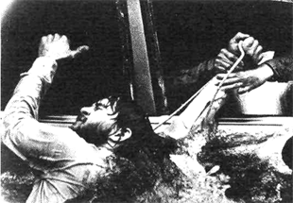
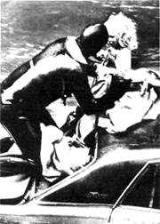
The driver of the truck, Paul Ruter, arrived before the other rescue workers. Immediately he took a rope from his truck and he began to walk through the rushing water to the car. Then he got into trouble, too. The water was too fast, the ground was slippery, and he got caught in the ropes. He went under the water by the car. Mrs. Cady saw him and reached for his hand. She pulled as hard as she could and brought him to the car door.
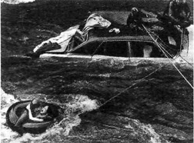
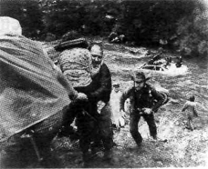
Next the other rescue workers arrived. They put on special suits to stay warm. They brought safety ropes, life jackets, tire tubes, and warm blankets. First they pulled the people out of the back window onto the top of the car. Then they swam with each person to shore. They saved Mr. Ruter, Mrs. Cady, and the little girls.
Finally all the people went to the hospital. Nobody was hurt badly. The rescue workers said that they all were very lucky to be alive.

Questions
1. Where did the trouble take place?
2. What kind of road was Mrs. Cady driving on when she lost control of her car?
3. How far did the car fall?
4. Why wasn't anybody hurt by the fall?
5. Why didn't they get out of the car?
6. How did the police learn about the trouble?
7. Where did Paul Ruter try to go?
8. Why did he slip under the water?
9. How did Mrs. Cady save Mr. Ruter?
10. What did the workers bring with them to help with the rescue?
11. How did the men save the four people?
12. What did the rescue workers say?

Using “Who” as the Subject of a Question
First student: Make a question about the subject of each sentence. Use who.
Second student: Answer each question with a short answer.
1. Rescue workers pulled four people from the water.
First student: Who pulled four people from the water?
Second student: Rescue workers did.
2. The mother and her two daughters got into trouble first.
3. Mr. Ruter almost died when he tried to save them.
4. Mrs. Leslie Cady lost control of her car.
5. Nobody was hurt by the fall.
6. Another driver told the police about the trouble.
7. Paul Ruter arrived first.
8. The other rescue workers arrived later.

Using “Who” as the Object in a Question
First student: Make a question about the object of each sentence. Use who did.
Second student; Answer each question with a complete sentence.
1. The police called special rescue workers.
First student: Who did the police call?
Second student: They called special rescue workers.
2. Mrs. Cady pulled Mr. Ruter to the car door.
3. Rescue workers pulled the little girls out of the back window.
4. They put the little girls on top of the car.
5. They swam with each person to shore.
6. They saved Mr. Ruter, Mrs. Cady, and the little girls.

Time Markers

lost, fell, rolled, landed
A series of verbs in the past tense is often used to tell about events that happen quickly, one right after the other. The story in this chapter is a series of quick, completed actions in the past. Almost every verb in the story is a punctual verb.
For stories like this, time markers of chronological sequence tell the order of actions. It is not possible to tell the relative order of events from the verbs themselves, since they are all in the same tense. The story includes words of chronological order like: first, second, almost immediately, before, after, then, next, and finally.
Below is a list of completed actions from the story. The list is out of order. Retell the story by using these sentences in the proper order and by using some of the words of chronological order.
1. The workers put on special suits to keep warm.
2. The car rolled over once.
3. Another driver saw Mrs. Cady's car.
4. Paul Ruter arrived.
5. He fell down into the rushing water and almost died.
6. The other rescue workers arrived.
7. Mrs. Cady lost control of her car.
8. The second driver called the police.
9. Ruter walked out to the car with a rope.
10. It landed right side in the rushing water.
11. Mrs. Cady was driving on a winding mountain road.
12. Mrs. Cady reached out to save the truck driver.
13. All four people went to the hospital.
14. They pulled the people onto the roof of the car.
15. They brought all four people safely to shore.

Changing Times, Changing Tenses
Repeat each sentence after your teacher. Then use a different time marker and change the tense to agree with the time marker.
1. Rescue workers pulled four people from the water last Friday. (just - at this minute)
2. People died in that water last year. (already - often)
3. Many cars have driven off that road already. (last winter - every year)
4. The car fell into the water two hours ago. (at this moment - just)
5. These people didn't wear seatbelts yesterday. (never- now)
6. The rescue started almost immediately. (right now - not yet)
7. Another driver is telling the police now. (already - half an hour ago)
8. She pulled him to the car door a minute ago. (not yet - now)

Pronunciation
After verbs which end in voiceless sounds, the past tense -ed ending is pronounced like /t/. The e of the -ed ending is not pronounced; there is no extra syllable added. Notice that there may be as many as three final consonants in the examples below.
Pronounce the words below.
missed decreased laughed
watched shopped oduced
looked stopped rushed
hoped asked reached

chapter twelve DINOSAURS LIVED MANY YEARS AGO
the past tense  PAST TENSE OF BE:  I was we were  you were  he, she, it was they were  VERB ( + ed)  AUXILIARY = did (for questions and negatives) | vocabulary:  dinosaur  disappear  shallow  Stegosaurus  develop  scales  protect  message  brain  serious  fossil

Reading Selection
Listen to the teacher read the selection. Then repeat as the teacher reads in phrases.
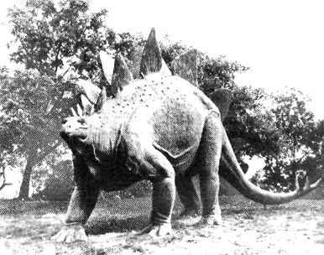
Dinosaurs lived on the earth for 135 million years. They appeared 200 million years ago, and they disappeared 65 million years ago. They were the largest animals ever to live on earth, and they ruled the earth for a very long period of time.
Dinosaurs lived in North America, in Africa, and in Europe. During this time, the land in North America was under a large, shallow sea. Many dinosaurs lived in the water, which helped to hold up their great weight. The early dinosaurs walked on two feet, and they ate meat. The later dinosaurs were larger and walked on four feet. Some of the later dinosaurs ate plants only.
The Stegosaurus was very large. It was a plant eater, but it was often in danger from the meat-eating dinosaurs. It developed scales along its back to protect itself.
The Stegosaurus was so large that it took a long time for messages to travel from its brain to its legs. To solve this problem, it developed a “second brain” by its back legs to control its leg movements.
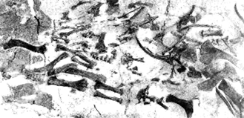
Why did dinosaurs die out? Nobody knows for sure. Probably a change in the weather made serious problems for them. About 70 million years ago, the Rocky Mountains formed in North America. The plant life and the weather changed. Perhaps the dinosaurs couldn't change fast enough.
People who like dinosaurs can see fossils in Dinosaur National Park. This park is in Utah and Colorado. Fossils are bones which have become stone. Fossils have taught us a lot about these great animals of the past.

Questions
First student: Make information questions with the questions words below.
Second student: Answer each question with a short answer.
1. Dinosaurs lived on the earth for 135 million years. (How long?)
First student: How long did dinosaurs live on the earth?
Second student: For 135 million years.
2. They appeared 200 million years ago. (When?)
3. They disappeared 65 million years ago. (When?)
4. They ruled the earth for a very long period of time. (How long?)
5. Dinosaurs lived in North America, in Africa, and in Europe. (Where?)
6. Many dinosaurs lived in the water, which helped to hold up their great weight. (Why?)
7. The Stegosaurus developed scales along its back to protect itself. (Why?)
8. The Stegosaurus developed a “second brain” by its back legs to control its leg movements. (Why?)
9. About 70 million years ago, the Rocky Mountains formed in North America. (When?)
10. Fossils are bones which have become stone. (What?)

Time Markers
were, lived, had, ruled Durative Verbs

appeared disappeared Punctual Verbs
died out
You have learned that the past tense can be used to describe a single point of time in the past. Punctual verbs in this chapter reading are: appear, disappear, die out, change, and form. These verbs mark the beginning and the end of the dinosaur period. The word ago is often used to fix an exact time in the past.
The past tense can also describe a period of time in the past, which began and ended in the past. Durative verbs which show a period of time are: be, live, have, and rule. Time markers which show the length of this time period are for (for 135 million years) and from to (from 200 million years ago to 65 million years ago).
Listen to the sentences below. If the verb describes a point in time, respond with the time marker “many years ago.” If the verb describes a period of time, respond with the time marker “for many years.”
1. Dinosaurs ruled the earth.
2. They appeared on the earth.
3. Dinosaurs lived in North America.
4. They disappeared from North America.
5. The land in North America was under a shallow sea.
6. The Stegosaurus developed a “second brain.”
7. Plant eaters and meat eaters lived together.
8. Dinosaurs died out.
9. The Rocky Mountains formed and the weather changed.
10. Dinosaur bones changed to stone.

Contrasting the Present Perfect Tenses with the Past Tense
Both the present perfect tenses and the past tense can describe a period of time. However, with the present perfect tenses, that period of time continues until the present. With the past tense, the period of time must both begin and end in the past. The activity is not happening in the present.
Listen to the following sentences. Tell whether or not the activity is still happening in the present.
1. Stella has been living in the same house for fifteen years. (She is still living there.)
2. Dinosaurs lived on the earth for 135 million years. (They are no longer living there.)
3. Dinosaurs ruled the earth from 200 million B.C. to 65 million B.C.
4. The police have been controlling our city since last year.
5. North America was under a shallow sea for many years.
6. Our car was under water for two hours.
7. That rescue worker has been under water for two minutes.
8. The weather has been very warm since last week.
9. The weather was very warm for 135 million years.
10. It rained last week from Wednesday to Friday.

Changing Times, Changing Tenses
Change each sentence from the present perfect to the simple past. Change the time marker as in the example.
1. I've studied English since 1973. (from 1971 to 1977)
I studied English from 1971 to 1977.
2. I've lived in England since 1975. (from 1974 to 1978)
3. I've had a job as a reporter since 1976. (from 1970 to 1975)
4. I've been working in the city since last year, (from 1972 to 1975)
5. The businessman has owned that store since 1940. (from 1940 to 1970)
6. He has controlled all business activities since 1960. (from 1960 to 1965)
7. She's been traveling around the world since last month. (from January to April)
8. She's been a private secretary since 1973. (from 1973 to 1974)
9. He's been driving his car every day since 1960. (from 1960 to 1970)
10. It's been raining since yesterday. (for two days last week)

Pronunciation
After verbs which end in /t/ or /d/, the past tense ending -ed is pronounced like /əd/. An extra syllable is added to the verb. Pronounce the words below.
acted needed celebrated
sounded visited painted
started decided landed
waited wanted protected

chapter thirteen
DRY LAND FARMING: AN ART AND A SCIENCE
the past tense PAST TENSE OF BE:  I was we were  you were  he, she, it was they were  VERB ( + ed)  AUXILIARY = did (for questions and negatives) | vocabulary:  crop  drought  dust  situation  Western Plains  Dust Bowl  science  art

Reading Selection
Listen to the teacher read the selection. Then repeat as the teacher reads in phrases.
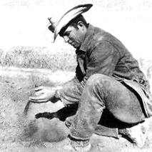
Before modern farming methods, farmers lost many crops to dry weather. Sometimes dry periods lasted for many years. In those days, a long dry period, or drought, often turned the land to dust. Then winds came along and blew the good land away. This happened year after year.
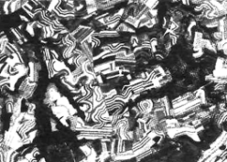
Farmers didn't understand how to plant and so they made the situation worse. Each year they planted the same crops. They never gave the land a rest. The land became poor with too much use. They always planted in long, straight rows. They broke the land into fine dust. They never planted trees to break the strength of the wind.
The worst dry period was the drought of the 1930's. Good farmland on the Western Plains became a Dust Source: W. Grant Heilman Wheat Country Bowl.

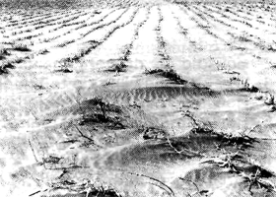
Farmers had a very hard time until they started to use modern farming methods.
Now farmers plant a different crop every year. Some years they give part of their land a rest. The land stays healthy and rich. Modern farmers form rows in curving lines and plant trees to stop the wind. Modern crops are much larger and more dependable.
Dry land farming is both a science and an art. From the air, the farms look like pieces of modern art.

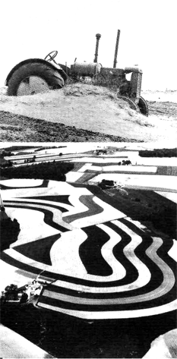
Questions
1. Why did farmers lose so many crops?
2. How did the drought change the land?
3. What did the wind do to the dust?
4. How long did the dry periods last?
5. How did farmers make the situation worse?
6. What happened on the Western Plains in the 1930's?
7. What methods do modern farmers use?
8. What are modern crops like?

Time Markers
Durative Verbs: lasted, had, became, understood

Punctual Verbs: lost, came, happened, planted, gave, broke, started, formed
The past tense can also be used to describe repeated, habitual actions for a period in the past. Repeated activity is usually expressed by punctual verbs. Many of the time markers are the same as in the present habitual tense: sometimes, never, always, often, each year, year after year.
Make sentences in the past tense with the groups of words below.
1. often / lose / crops
2. drought / usually / turn land to dust
3. happen / year after year
4. always / plant / straight rows
5. never / give land / rest
6. usually / break land / into dust Source: Departmenl of Agriculture Don Schuhart
7. never / form / curving rows
8. never / plant / trees

Contrasting the Past Tense and the Present Habitual
Listen to the sentences below. Then tell whether the activity still happens, or whether it doesn't happen any more.
1. Farmers lost many crops before they used modern methods.
(They don't lose many crops any more.)
2. Crops are large and dependable.
(Crops are still large and dependable.)
3. Dry periods last for many years.
4. Droughts often turned the land to dust in those days.
5. Year after year the winds blew the good land away.
6. Farmers use modern methods.
7. Farmers planted the same crops every year.
8. They always planted in long, straight rows.
9. Farmers sometimes give the land a rest.
10. Farmers broke the land into dust.
11. They plant rows of trees to break the wind.
12. Farmers had a lot of trouble with drought.

Changing Times, Changing Tenses
The problem of drought and dry land farming has been solved. Pretend that another problem—that of litter in modern cities—was solved some years ago. Retell the story in chapter one, “Litter is a Problem in Our Cities,” using the past tense. Begin this way:
Litter Was a Problem in Our Cities
Before people decided to stop throwing garbage, litter was a big problem in our cities.

Pronunciation
In questions in formal spoken English, there is often a reduction in sound after the auxiliary verb did. The change in sound may involve the question word, the verb did, and the following pronoun. Pronounce the sentences below.
1. Did you lose your crops?
2. Did you give the land a rest?
3. Did your land dry out?
4. Didn't you plant trees?
5. Didn't you plant in curving rows?
6. What did the wind do to the dust?
7. When did it blow?
8. Where did it blow?
9. Why did it hurt the crops?
10. How did it change the land?
11. Who did it hurt?
12. How long did it last?

Unit Five: The Past Habitual Tenses

chapter fourteen
TRANSPORTATION USED TO BE MUCH SLOWER THAN IT IS NOW
the past habitual tense  USED TO + VERB  AUXILIARY = did + use to + VERB,  for questions and negatives | vocabulary:  desert biplane  camel pilot  transportation load  mechanical engine  improvement tank  refrigerator cabin  monoplane jet

Reading Selection
Listen to the teacher read the selection. Then repeat as the teacher reads in phrases.

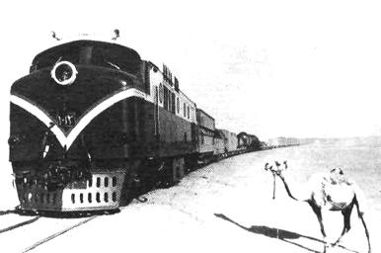
For many years in the desert, camels used to be the only form of transportation. Before the age of modern trains, camel trains used to carry all the goods for trading between Central Africa and Europe. Traders sometimes used to put together camel trains with 10,000 to 15,000 animals. Each animal often used to carry as much as 400 pounds and it could travel twenty miles a day. This form of transportation used to be so important that camels were called the “ships of the desert.”
Now modern trains travel across the desert in a very short time. One engine can pull as much weight as 135,000 camels. In addition, trains use special cars for their load. Refrigerator cars carry food; boxcars carry heavy goods; stock cars carry animals; and tank cars carry oil.
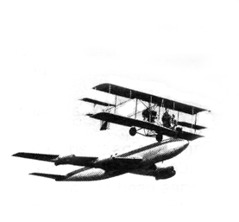
Air travel has changed, too. The earliest planes were biplanes, with two sets of wings. The top speed of this plane was 60 miles per hour. The pilots used to sit or lie on the wings in the open air. The plane engines sometimes used to stop in the middle of a trip. It used to be impossible to fly in bad weather. In snow or in rain, the wings frequently used to become icy. Then the plane might go down.
Mechanical improvements during the first world war changed airplanes. Monoplanes took the place of biplanes. Pilots flew inside of covered cabins. Still, even these planes were small. Only rich people used to be able to travel in airplanes.
Now modern jets make air travel possible for all people. No place in the world is more than 24 Source: Boeing Airplane Co. hours away by jet. Further improvements have lowered the cost of flying, and they have made air travel much safer than it used to be. A modern 707 can carry 170 people and can fly at 600 miles per hour. People never used to eat, sleep, or watch movies on airplanes. Now these things are a normal part of air travel!

Questions
1. What used to be the only form of transportation in the desert?
2. How many camels did traders use to put together in camel trains?
3. How fast did the camel trains use to move?
4. How much weight did the camels use to carry?
5. What did people use to call the camels?
6. Explain why air travel used to be so dangerous.
7. Did pilots use to travel in bad weather?
8. Who used to travel on airplanes?
9. What did air travel use to cost?
10. Did people use to eat and sleep on planes?

Making Questions with “Used to”
First student: Change each sentence into a question.
Second student: Answer each question with a short answer.
1. Camels used to carry all the goods between Central Africa and Europe.
2. Camel trains used to be very important.
3. Traders didn't use to keep food cold.
4. Planes used to have two sets of wings.
5. Pilots used to sit or lie on the wings.
6. The wings sometimes used to ice up in bad weather.
7. Poor people never used to ride in airplanes.
8. Air travel used to be more dangerous.
9. Air travel used to be more expensive.
10. Airplanes used to be much smaller.

Time Markers
used to be
used to be able to
used to carry
used to travel
used to fly
In chapters twelve and thirteen, you learned that the past tense could be used to describe a period of time in the past. Another verb tense which is used for this time picture is the past habitual tense with “used to.” The past habitual can describe a state or an activity which lasted for a period of time; it can also describe repeated, habitual actions for a period of time in the past. The adverbs of frequency are often used with this tense.
The past habitual resembles the present tense (present habitual) in some ways. It is like a small section of the present tense, but its time period ends before present time. Statements with “used to” are no longer true in the present.
Below is a conversation between an old man and a modern traveler. Finish the sentences for the modern traveler; use the past habitual tense.
1. “I have many camels for desert trade.” (before the days of the modern train)
“I used to have many camels for desert trade before the days of the modern train.”
2. “I always send my goods on camels.” (before the days of the modern train)
3. “I ride my camels every day.” (before I sold them all)
4. “My camels often travel twenty miles a day.” (before they got old)
5. “Camel trains leave every week to cross the desert.” (in the old days)
6. “Camels are very important to trade.” (in the old days)
7. “Airplanes are too dangerous to fly in.” (before modern improvements were made)
8. “I'm afraid of flying.” (before I tried it)

Contrasting Tenses: Listening Discrimination
Used to + Verb
to Be Used to + Verb + ing
Do not confuse these two verb tenses. The second one means to be accustomed to something. It is followed by a verb + ing. Compare these sentences:
I am used to riding on camels (and I will continue.)
I used to ride on camels (but I don't any more.)
Listen to the sentences below as your teacher reads them. Decide which form is being used. Respond by saying either “and they will continue” or “but they don't any more.”
1. Camels used to carry heavy weights.
2. Camels are used to carrying heavy weights.
3. Traders are used to putting together camel trains.
4. Traders used to put together camel trains.
5. Pilots are used to sitting on the wings.
6. Pilots used to sit on the wings.
7. Pilots used to fly in dangerous weather.
8. Pilots are used to flying in dangerous weather.
9. Rich people are used to flying in airplanes.
10. Rich people used to have the airplanes for themselves.

Time Lines
Make sentences with the verbs below. Use the tense which is indicated in each time line.
1. 2.
used to travel travel
3. 4.
used to carry carry
5. 6.
has changed used to stop
7. 8.
changed took the place of
9. 10.
have lowered eat, sleep, watch movies

Changing Times, Changing Tenses
Retell the story in chapter thirteen, “Dry Land Farming: An Art and a Science”. Use the past habitual with “used to” whenever it is possible.

Pronunciation
In normal spoken English, the second vowel in “used to” is reduced to /ə/. Notice also that the final d in “used” combines with the following t, so there is actually no difference in sound between the phrases “used to” and “use to.”
Pronounce the sentences below.
1. Camel trains used to be very important.
2. Did camel trains use to be very important?
3. Planes used to have two wings.
4. Did planes use to have two sets of wings?
5. The wings used to ice up.
6. Did the wings use to ice up?

chapter fifteen THANKSGIVING ON THE FARM
the past habitual tense with WOULD  WOULD + VERB | vocabulary:  relative twin  extra onion  stove roast  turkey dozen  stuff pie

Reading Selection
Listen to the teacher read the selection. Then repeat as the teacher reads in phrases.

I remember our Thanksgivings on the farm. When I was growing up, we lived on a farm near the town. There were many other relatives who lived near us. Every year they would all come, from other farms and from the town, to be with us.
We'd work for days to prepare for the holiday. Mother and the girls would clean every part of the house, and they'd get all the extra rooms ready for the relatives. Then they'd wash all our best clothes—we called these dresses and suits our “Sunday best.” The men would cut extra wood for all the cooking, for we had an old wood-burning stove. Father would always kill the biggest turkey, and then he'd clean the bird. Finally, the whole 1arm\y would drive into town to buy the food that we couldn't produce on the farm, like coffee and sugar.
On Thanksgiving morning the women would get up early to begin cooking. Mother would stuff the turkey with bread and onions, and then she'd roast it. Aunt Ellen would make a dozen pumpkin pies. Aunt Ann would pick autumn flowers from the garden for the center of the table. She'd also bring in vegetables to eat with the turkey and the pies.
The older children would help set the table while the twin babies played in their high chair. But I liked to play with the cat, waiting for somebodytogivemepiecesof food. All this time our old dog would lie under the warm stove, watching the activity.
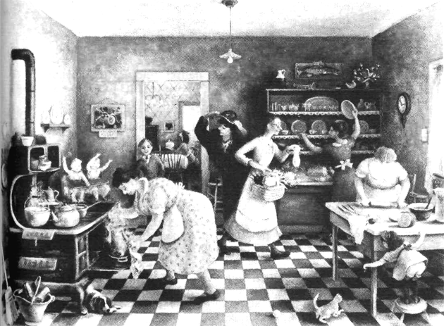
Source: Artist Doris Lee.
The Art Institute of Chicago

Questions
1. Where did the woman live when she was growing up?
2. Where did her relatives live?
3. Why would her relatives visit at Thanksgiving time?
4. How long would the family work to prepare for the holiday?
5. What would the women do to get ready for Thanksgiving?
6. What would the men do to help?
7. What would the family do all together?
8. What foods would the women cook on Thanksgiving Day?
9. What would the older children do to help?
10. Where would the dog and cat be?

Time Markers

would clean, would wash, would drive, would get up, would roast, would pick
The time picture for this tense is the same as the picture for the past habitual tense with “used to,” from chapter fourteen. Notice, however, that the verbs in this reading selection are punctual verbs rather than durative verbs. The phrase “would be” does not mean the same thing as the phrase “used to be.” Most English speakers understand “would be” as a future conditional, in future time, rather than as a past habitual.
Common time markers are the adverbs of frequency, as well as combinations with every (every year, every month, every time, every Thanksgiving Day). In addition, another time marker is used to set the period in the past: in my youth, when I was young, in the old days, before modern times.
Listen to each sentence as your teacher reads it. Then use a past time expression and repeat the sentence in the past habitual tense with would.
1. Our relatives visit every year at Thanksgiving time. (In my youth)
In my youth, our relatives would visit every year at Thanksgiving time.
2. They come every year to be with us. (Formerly)
3. We usually work for days to prepare for the holiday. (When I was young)
4. Mother and the girls always clean every part of the house. (In those days)
5. We wash our best clothes every week. (In the old days)
6. The men cut wood every day for cooking. (In my youth)
7. The family shops in town every week. (When I was young)
8. The women always get up early to cook. (In those days)
9. Aunt Ellen sometimes makes fruit pies, and sometimes she makes pumpkin pies. (When I was young)
10. Aunt Ann often picks flowers from the garden. (Jn the old days)
11. The older children help set the table for every meal. (Formerly)
12. Our old dog often watches from under the stove. (In those days)

Changing Times, Changing Tenses
Retell the story in chapter fourteen, “Transportation Used to Be Much Slower,” using would whenever it is possible. Do not substitute “would be” for “used to be.”
Retell the story in this chapter, using used to. It will be possible to substitute used to for any phrase with would.

Pronunciation
In normal spoken English, the pronouns and the word not contract with the auxiliary would. There is no change in the vowel sounds. Pronounce the words below.
I, I'd we, we'd
you, you'd they, they'd
he, he'd
she, she'd would, wouldn't
it, it'd

Unit Six: The Past Continuous Tense

chapter sixteen WHEN THE WALL FELL IN
the past continuous tense  BE + VERB + ing (past) | vocabulary:  dig  accident  crack  refuse  shock  insurance

Reading Selection
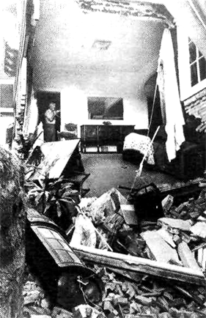
Listen to the teacher read the selection. Then repeat as the teacher reads in phrases.
At six o'clock on April 21,1976, the living room and front part of this man's house fell in. The man was having construction workers dig a hole under the front of the house to add on another room. The workers weren't there when the accident happened, so nobody was hurt.
Reporters asked the owner, “What were you doing when the rooms fell in?”
He answered, “My wife and I were talking to guests. We were showing them the cracks in the front room when we heard a loud sound. The cracks were growing larger, so we called the construction company. But it was too late. The construction workers were still driving here when the rooms fell in.”
The owner's wife was cry ing while the reporters were talking and refused to have her picture taken.
“I was standing right here outside the front room when it fell in,” she said. “It gave me the biggest shock of my life.”
The owner has told his insurance company about the accident, and it will pay to rebuild the house. The construction company says that the house will soon be as good as new. But many of the things in the house have been lost forever.

Questions
Answer each question with a complete sentence.
1. When did the rooms fall in?
2. Why wasn't anybody hurt?
3. Who was the owner talking to when the rooms fell in?
4. What was he looking at when he heard the sound?
5. Why did he call the construction company?
6. What were the workers doing when the rooms fell in?
7. What was the owner's wife doing while the reporters were talking?
8. Where was she standing when the front room fell in?
9. Who will rebuild the house?
10. Who will pay for the repairs?

Time Markers

The past continuous tense is rarely used by itself. Rather, it is used to describe what was taking place when another activity happened in the past. Usually the past continuous is joined to another clause in the past continuous or in the past tense. The time lines took like this:
talking talking

crying fell in
She was crying while the reporters They were talking to their guests
were talking. when the rooms fell in.
While she was crying, the reporters While they were talking to their
were talking. guests, the rooms fell in.
The time marker while introduces clauses in the past continuous; when introduces clauses in the past tense.
Join the following pairs of sentences with the time marker while.
1. The construction workers weren't working.
The owners were talking to their guests.
2. The cracks were growing larger.
The people were looking at them.
3. The workers were driving to the man's house.
The rooms were falling in.
4. The owner's wife was crying.
The reporters were talking to her.
5. The owner was looking at the house.
The reporters were taking his picture.
Join the following pairs of sentences with the time marker when.
1. It was raining. Lightning struck the tree.
2. We were watching TV. Lightning struck.
3. I was sitting by the window. I heard the sound.
4. Nobody was standing near the tree. The lightning hit.
5. We were looking out the window. We saw a flash of light.
Join the following pairs of sentences, first with while and then with when.
1. Mrs. Cady was driving on a mountain road. She lost control of her car.
2. Everybody was wearing seatbelts. A bad accident happened.
3. Mr. Ruter was walking through the water. He fell.
4. He was trying to save the people. He got into trouble himself.
5. Mrs. Cady was watching him. He went under water.

Noncontinuous Verbs
As you have learned, some verbs cannot be used in the continuous tenses. (See chapter six for a review.) When you are speaking or writing about past time, such verbs will take the past tense instead of the past continuous.
Listen to the following sentences as your teacher reads them. Change each verb to past continuous if it is possible. If the verb does not take a continuous tense, simply repeat the sentence as it is.
1. Construction workers dug a hole yesterday.
2. He wanted another room,
3. They added on another room.
4. They didn't work there last night.
5. My wife talked to our guests.
6. We showed them the cracks in the front room.
7. We heard a loud sound.
8. We called the construction company.
9. It was too late.
10. The rooms fell in.
11. We needed more room.
12. We had more rooms before the accident.

Time Lines
Make sentences with the verbs below. Use the tense which is indicated in each time line.
1. 2.
fell in showing fell in driving
3. 4.
heard growing fell in crying
5. 6.
showing talking
7. 8.
has told have been lost

Changing Times, Changing Tenses
Retell the story in chapter five, “The Kites Are Flying High.” Use the past continuous tense and answer the question, “What were these people doing on their vacation yesterday?”

Unit Seven The Past Perfect Tenses

chapter seventeen
NOBODY HAD BELIEVED IT WAS POSSIBLE
the past perfect tense  HAD + PAST PARTICIPLE | vocabulary:  iceberg tragedy  lifeboat officer  sink drill  passenger warning  radio speed  survivor direction

Reading Selection
Listen to the teacher read the selection. Then repeat as the teacher reads in phrases.
In 1912, the Titanic hit an iceberg on its first trip across the Atlantic, and it sank four hours later. At that time, the Titanic was the largest ship that had ever traveled on the sea. It was carrying 2207 people, but it had taken on enough lifeboats for only 1178 people. When the passengers tried to leave the ship, only 651 of them were able to get into lifeboats.
The Carpathia was 58 miles away when the Titanic called on its radio for help. It arrived two hours after the great ship had gone down, and it saved 705 people. Some of the survivors had been in the icy water for hours when they were saved. Most of the passengers hadn't lived that long; 1502 people had lost their lives.
Through the whole tragedy, the Cafifornian was only ten miles away. Its officers were close enough to see the Titanic, but they didn't understand the situation. They never received the Titanic's call for help, and they didn't come to the rescue until too late.
Why was there such a great loss of life? Why were there so few survivors? Why didn't the Californian come to help?
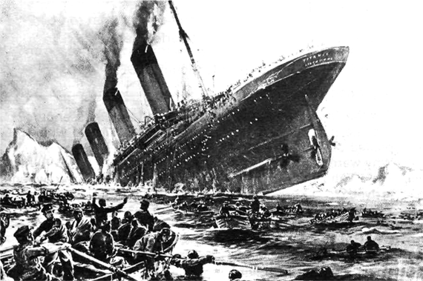
First of all, nobody had prepared for such a tragedy. Nobody had believed that the Titanic could sink. The steamship company had thought that its ship would be completely safe in ail situations. They'd followed an old rule for the number of lifeboats, so they'd supplied lifeboats for only half the people. The passengers had not yet received their lifeboat numbers, nor had they practiced lifeboat drill before the accident. Many of them had not even dressed warmly, for the ship had hit the iceberg late at night, and they didn't believe they were in danger.
The ship had already received six ice warnings on its radio when it struck the iceberg. Nevertheless, it had not changed its direction or its speed. It was impossible to change direction quickly enough when the iceberg came in sight. When the Titanic hit the iceberg, the radio officer on the Californian had just gone to bed. He'd tried to warn the officers on the Titanic about the ice before he'd gone to bed, but the officers hadn't listened.
After this accident, ocean travel changed. Now there are always enough lifeboats for everybody. Ships don't go so far north in winter, and they watch carefully for ice. Radio officers work 24 hours a day. A tragedy like the sinking of the Titanic should never happen again.

Questions
Answer each question in the past perfect tense.
1. Did the Titanic cross the Atlantic in 1913?
No, it had already sunk in 1913.
2. Did the Titanic have enough lifeboats for its passengers?
3. Did the people on the Carpathia see the Titanic when they picked up the survivors?
4. Why were the survivors so cold?
5. Why didn't the Carpathia pick up more passengers when it arrived?
6. Why hadn't the steamship company prepared for the tragedy?
7. Why were there so few lifeboats?
8. Why didn't the passengers know where to go?
9. Why were some of the survivors so wet?
10. How did the officers know there was ice on the sea?
11. Was the Titanic traveling carefully?
12. Did the radio officer on the Californian hear the call for help?

Time Markers
Like the present perfect tense, the past perfect tense has two uses. The first use is to show an action which was completed before a second time in the past. In this chapter's reading selection, one point in time serves as a reference point: the time when the Titanic hit the iceberg. That is a past action; everything that comes before it is in the past perfect tense.
As in the present perfect tense, punctual verbs usually show completed actions. Common time markers are already, just, and yet. Notice the following sentences and their time lines.
1.
had received struck
The ship had already received six ice warnings on its radio when it struck the iceberg.
2.
( )

( )

had not received, had not practiced accident
The passengers had not yet received their lifeboat numbers, nor had they practiced lifeboat drill before the accident.
3.
had gone hit
When the Titanic hit the iceberg, the radio officer on the Californian had jusf gone to bed.

Interpreting Past Perfect Sentences
When a past perfect tense is used in the same sentence with a past tense, the order of events is clear from the tenses themselves. The past perfect action happened first. Chronological markers such as before and after are not necessary. The word when can be used to join such sentences.
Read each sentence. Tell what happened first and what happened next.
1. Only 651 people had gotten into lifeboats when the Titanic sank.
First 651 people got into the lifeboats. Then the Titanic sank.
2. The Titanic had already gone down when the Carpathia arrived.
3. Some passengers had been in the icy water for hours when they were saved.
4. When the Carpathia arrived, about 1500 people had already lost their lives.
5. The passengers had not practiced lifeboat drill when the accident happened.
6. When it hit the iceberg, the ship had already received six ice warnings.
7. The radio officer had just gone to bed when the accident happened.
8. He had already sent a warning to the officers of the Titanic when he went to bed.
9. The ship had not changed its direction or speed when it hit the iceberg.
10. When the passengers left the ship, they had not dressed warmly.

Listening Discrimination
Listen to the following sentences as your teacher reads them. Tell whether the two events in each sentence happened at the same time or at different times.
1. The passengers had received their numbers when the accident happened.
2. The passengers received their numbers when the accident happened.
3. The officers hadn't believed in the danger when they heard the ice warnings.
4. They believed in the danger when they saw the iceberg.
5. The ship sounded a warning when it started to sink.
6. The ship hadn't sounded a warning when it struck the ice.
7. The officer hadn't changed his speed when he saw the iceberg.
8. The officer changed his direction when he saw the iceberg.
9. The radio officer went to bed when he was tired.
10. He had gone to bed when the accident happened.
11. The officers listened when sea water rushed into the ship.
12. The officers hadn't listened when they heard the ice warnings.

Retelling the Story
Below is a list of events that happened when the Titanic sank. The list is out of order. Retell the story by using these sentences, in the proper order. Make the time relationship clear by using some past perfect tenses and some past tenses.
1. The Titanic hit an iceberg.
2. The passengers tried to leave the ship.
3. The Titanic sank.
4. The Carpathia arrived.
5. The Titanic received an ice warning from the Californian.
6. The radio officer on the Californian went to bed.
7. The Titanic called for help.
8. The Carpathia picked up 705 people.
9. 1502 people died in the cold water.
10. The Californian came to the rescue.

Changing Times, Changing Tenses
Retell the story in chapter eleven, “Rescue Workers Saved Four People.” Show the relationships of the events by using some past perfect tenses.

Pronunciation
In normal spoken English, the pronouns and the word not contract with the auxiliary had. There is no change in vowel sounds. (The contractions sound just like the contractions with would.)
I'd = I had, I would we'd = we had, we would
you'd = you had, you would they'd = they had, they would
she'd = she had, she would
he'd = he had, he would
it'd = it had, it would hadn't = had not
Listen to the following sentences as your teacher reads them. Decide if they are in the past perfect or in the past habitual tense with would. Respond by saying either had or would.
1. They'd dress warmly.
2. They'd follow an old rule.
3. They'd dressed warmly.
4. They'd supply half the lifeboats.
5. They'd followed an old rule.
6. They'd supplied half the lifeboats.
7. They'd call the Titanic.
8. They'd called the Titanic.
9. They'd traveled too far north.
10. They'd travel too far north.

chapter eighteen HUSKY HAD BEEN VERY HEALTHY
the past perfect tense  HAD + PAST PARTICIPLE | vocabulary:  Navajo Indian  reservation  catch a cold  fever  lap  infection

Reading Selection
Listen to the teacher read the selection. Then repeat as the teacher reads in phrases.
Husky Yellowhair is a little boy on the Navajo Indian Reservation in Arizona. It's difficult for his family to get to a doctor, because they don't have a car or a telephone. Their closest neighbors live ten miles away.
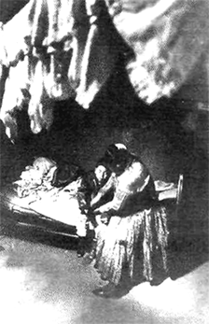
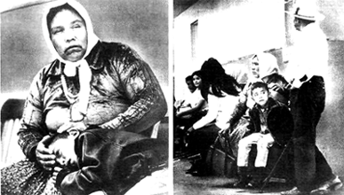
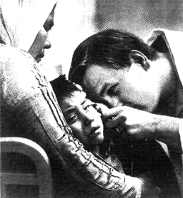
Last month Husky had caught a cold. He'd felt sick for three days, so his mother wanted to bring him to a doctor. She'd kept him in bed the whole time, and she'd given him medicine every day for three days. Still, he didn't feel any better. On the third day, he developed a fever. At that time, Husky's parents asked some friends to take them to the hospital.
At the hospital, Husky tried to sleep. He put his head in his mother's lap. From time to time he looked for the doctor, but he didn't really want to see him. Husky had always been afraid of doctors and hospitals. Up to that time, Husky had been very healthy, so he hadn't seen many doctors. As he waited, he grew more afraid. The family had waited for an hour when the doctor came.
The young doctor found the problem immediately. The cold had gone to Husky's ears, and he'd developed an ear infection. Although it wasn't a serious disease, it had caused the pain and the fever. With stronger medicine, Husky would be well soon.

Questions
1. Why is it difficult for the Yellowhair family to get to a doctor?
2. How long had Husky been sick when his parents brought him to the doctor?
3. What had Mrs. Yellowhair done to help her son before taking him to the hospital?
4. What happened to Husky on the third day of his sickness?
5. Had Husky had a fever before the third day?
6. How did Husky feel at the hospital?
7. Had Husky been quite healthy before his sickness?
8. How long had the family waited when the doctor came?
9. Why had Husky developed a fever?
10. What had caused the pain?

Time Markers
Like the present perfect tense, the past perfect may be used with durative verbs to describe an activity or a state over a period of time. Some durative verbs in this chapter are: feel, keep, grow, be, and wait. Common time markers show both the length of time (for three days, for an hour, up to that time, the whole time) and the time of the second action in the past (when the doctor came). The second action in the past is usually a punctual verb which marks the end of the time period of the durative verb. In this time picture, the first X represents the beginning of the activity (waiting), the dark arrow represents the length of time the family had waited, and the second X marks the end of the wait, when the doctor came.
had waited

came
The family had waited an hour when the doctor came.
When punctual verbs are used in this time picture, they may give the idea of repeated action over a period of time. They are used with time markers which show habitual or repeated action in a time period (every day for three days, from time to time). In this time picture, the dark arrow represents the length of time that Husky's mother gave him medicine; the small X's show how many times she gave the medicine; and the last X shows the end of the time period (when she brought him to the hospital).

had given had given had given brought
Husky's mother had given him medicine every day for three days before she brought him to the hospital.
Use each time marker and verb below to make a sentence about the story.
1. stay in bed / for three days
2. take medicine / every day for three days
3. feel sick / the whole time
4. try to sleep / for an hour
5. be afraid / before his sickness
6. worry about the doctor / for three days
7. worry about her son / for three days
8. be healthy / before his sickness
9. wait / for an hour when the doctor came
10. look / again and again / for an hour
11. talk to her husband / from time to time
12. have an infection / for two days

Interpreting Past Perfect Sentences
Read each sentence. Tell what happened first. Then tell how long it continued. Finally, tell what happened last.
1. The Yellowhairs had lived in the city for five years before they moved to the reservation.
First the Yellowhairs lived in the city.
They lived there for five years.
Then they moved to the reservation.
2. They had had a car and a telephone before they moved to the reservation.
3. He had been sick for three days when he developed a fever.
4. She had kept him in bed for three days before she took him to a doctor.
5. He had waited in his mother's lap for an hour when he saw the doctor.
6. The infection had caused pain and fever for two days before the doctor found it.

Time Lines
Make sentences with the verbs on next page. Use the tense which is indicated in each time line.
1. 2.
is live
3. 4.
had felt developed
5. 6.
asked tried to sleep
7. 8.
has waited had gone

Changing Times, Changing Tenses
Retell the story in chapter eight, “It's Difficult to Say Good-bye.” Use past perfect tenses.

chapter nineteen
LUCKILY, I HAD BEEN WEARING MY SEATBELT
the past perfect continuous tense  HAD + BEEN + VERB + ing | vocabulary:  freeze  melt  check  traffic  regularly  slip

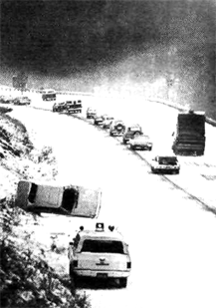
Reading Selection
Listen to the teacher read the selection. Then repeat as the teacher reads in phrases.
The snowstorm in our city last week wasn't a large one, but it caused many accidents. The snow started to come down in the late afternoon. I saw it through the window of the office building where I work as a secretary. It had been snowing for an hour when I started to drive home.
The cars had been driving slowly because of the dangerous roads. It was slippery snow that froze when it hit the roads. Earlier, the snow had been melting, but by evening it was staying on the roads. Police cars had been checking the traffic regularly.
I'd been driving for twenty minutes when the accident happened. My heater hadn't been working, and the snow had been freezing on my window, so I couldn't see well. I'd been stopping to clean my window every few minutes. I'd just started the car again when my tires started to slip. The car slipped onto the side of the road. When it hit the hill, it turned over and stopped.
I felt and looked to see if I was hurt, but I wasn't. I'd been driving quite slowly, and luckily I'd been wearing my seatbelt. It was very quiet, with just the sounds of music and falling snow; I'd been playing the radio. Soon the police came to help me, and I was able to reach home in another hour.

Questions
Answer each question with a sentence in the past perfect continuous tense.
1. Did it begin to snow just as the secretary started to drive home?
No, it had already been snowing for an hour when she started to drive home.
2. Why was the traffic so slow?
3. How do we know that it had been warmer earlier in the day?
4. How do we know that the weather became colder before the accident?
5. What job had the police been doing?
6. How long had the secretary been driving when she had the accident?
7. Why couldn't she see well?
8. Why had she stopped so often?
9. Why wasn't the secretary hurt?
10. Why was the radio playing after the accident?

Time Markers
The past perfect continuous tense has the same time line as the durative part of the past perfect tense. They are both used to describe a period of time. When used with durative verbs, the past perfect continuous describes an activity or a state which began in the past and lasted until a second time in the past.
had been snowing

started to started to
snow drive
It had been snowing for an hour when I started to drive home.
Some durative verbs in this story are: snow, drive, melt, stay, work, freeze, wear, fall, play. Common time markers show both the length of time (for an hour) and the time of the second action in the past (when I started to drive home).
When the past perfect continuous is used with punctual verbs, it describes repeated action within a time period, before a second past time.
had been checking

accident
happened
Some punctual verbs in this story are: stop, check, start. They are used with time markers that show habitual action within a time period (regularly, every few minutes).
Use each time marker and verb below to make a sentence about the story.
1. stay at work / regularly / before the snowstorm last week
2. snow / fall / for an hour before I left work
3. snow / melt / before the weather turned cold
4. snow / freeze on the roads / since the weather turned cold
5. drive / for a few minutes / when my window was covered
6. stop / every few minutes / to clean the window
7. wear / my seatbelt / before the accident happened
8. play / radio / before the car turned over
9. police / drive past / every few minutes / before the accident happened
10. wait / for ten minutes / when the police arrived

Interpreting Past Perfect Continuous Sentences
Read each sentence. Tell what happened first. Then tell how long it continued. Finally, tell what happened last.
1. It had been snowing for an hour when I started to drive home.
First it started snowing.
It snowed for an hour.
Then I started to drive home.
2. The snow had been melting all day until the evening came.
3. I'd been driving for twenty minutes when the accident happened.
4. The snow had been freezing on my window for several minutes, so I couldn't see well.
5. I'd been driving for just a few minutes when my tires started to slip.
6. I'd been wearing my seatbelt the whole time before the car turned over.
7. I'd been playing the radio forten minutes before the car turned over.
8. I'd been waiting ten minutes when the police came.

Noncontinuous Verbs
As you have learned, some verbs cannot be used in the continuous tenses. (See chapter six for a review.) When you are speaking or writing about a time before past time, such verbs take the past perfect tense.
Listen to the sentences as the teacher reads them. If you can, change each sentence to the past perfect continuous tense. If the verb cannot take a continuous tense, simply repeat the sentence as it is.
1. The winter had been very cold.
2. The snow had caused quite a few accidents.
3. The snow had come down all day.
4. I'd seen the snow through my office window.
5. I'd worked in that office for ten years.
6. I'd had my car for all ten of those years.
7. I'd liked the car very much.
8. I'd thought about getting home early.
9. It had seemed quite warm outside.
10. I hadn't known the roads were so slippery.
11. I'd stopped every few minutes along the way.
12. I'd worn my seatbelt the whole time.

Action Completed and Activity Over a Period of Time
The past perfect continuous tense is not used to describe completed action; for that time picture, we use the past perfect. Listen to the sentences below as your teacher reads them. All are in the past perfect tense; some of the verbs describe a period of time, and some describe a completed action. If the verb describes an activity over a period of time, change it to the past perfect continuous tense. If it describes a completed action, simply repeat the sentence as it is.
1. The snow had already started to come down at 5:00.
2. All the cars had driven slowly for many hours.
3. I'd checked my heater already that morning.
4. The heater hadn't worked for a week.
5. I'd driven for twenty minutes when the accident happened.
6. I'd driven halfway home when it happened.
7. I'd stopped to buy gas before I started.
8. I'd stopped every five minutes to clean the window.
9. I'd just started the car again when my tires slipped.
10. I'd started the car every ten minutes to keep it warm.

Changing Times, Changing Tenses
Retell the story in chapter eighteen, “Husky Had Been Very Healthy.” Use the past perfect continuous when you can.
Retell the story in chapter nine, “Are Buses as Easy to Use as Cars?” Change it to past time and use the proper past and past perfect tenses.

Unit Eight: The Future Tenses

chapter twenty THE CAR OF THE FUTURE
the future tense  WILL + VERB | vocabulary:  pessimist optimist  gas solve  speed Supercar  air conditioning comfortable  swimming pool

Reading Selection
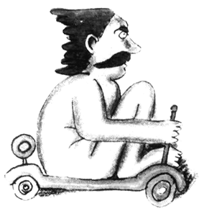
Listen to the teacher read the selection. Then repeat as the teacher reads in phrases.
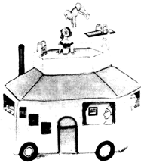
A pessimist is a person who always expects bad things to happen. Pessimists think that today's cars are in trouble because they use too much gas. They say the car of the future will be much, much smaller. The car of tomorrow will have no heater and no air conditioning. It'll have no radio and no lights. Tomorrow's car will be an open air car with no doors and windows. It won't need a pollution control system because it won't use gas. In fact, drivers will push this new car with their feet. Very few people will be killed in accidents, because the top speed will be five miles per hour. However, pessimists warn us not to ask for pretty colors, because the car will come in gray only.

Source: Artist Martin Rubin, Ths Lamp Magazine
Optimists are sure that the future will be happy. They think that car companies will soon solve all our problems by producing the Supercar. Tomorrow's car will be bigger, faster, and more comfortable than before. The Supercar will have four rooms, color TV, running water, heat, air conditioning, and a swimming pool. Large families will travel on long trips in complete comfort. If gas is in short supply, the Supercar will run on water. Finally, optimists promise that the car of the Sourca: Artist Martin Rubin,
future will come in any color, as long as the color is gray. The Lamp Magazine

Questions
1. What is a pessimist?
2. Why are today's cars in trouble?
3. What will the car of the future look like, according to the pessimists?
4. Why won't it need a pollution control system?
5. How will it run?
6. Why will it be so safe?
7. How many colors will it come in?
8. What is an optimist?
9. How will car companies solve our problems?
10. What will the Supercar look like?
11. How will it run?
12. How many colors will the Supercar come in?

Time Markers
Durative verbs: will be, will have, will need

Punctual verbs: will come, will use, will travel
The future tense with will describes actions, activities, and states in the future. Common time markers use combinations with next (next year, next week, next month) with in (in the future, in two years, in ten days), and with from now (ten years from now, six weeks from now).

Changing Time Markers
Repeat each sentence after your teacher. Then use a different time marker and change the tense to agree with it.
1. Cars will be much, much smaller in the future. (since the gas shortage; before modern times; fifty years ago)
Cars have been much, much smaller since the gas shortage.
Cars used to be much, much smaller before modern times.
Cars were much, much smaller fifty years ago.
2. The cars of tomorrow will have no heater and no air conditioning. (today—often; fifty years ago; a few years from now)
3. Cars these days need pollution control systems. (in the future; last year; next year)
4. The driver always pushes his car with his feet. (next year; since the gas shortage; now)
5. Automobile accidents will kill many people in the future. (already; these days; every day)
6. The car comes in gray only. (next year; for many years; last year)
7. Car companies have just solved all our problems. (in two years; right now; six months from now)
8. In my youth, large families used to travel on long trips. (in a few years; these days; often)

Clauses as Time Markers
will be

will drive
Sometimes an entire clause can be used as a time marker. Two shorter future tense sentences can be combined into one sentence. The verb in the time clause, after the conjunction when, must take a present tense. This is true even though the time is still future time.
Combine the pairs of sentences below.
1. People will be safer. They will drive in slower cars.
People will be safer when they drive in slower cars.
2. Cars will use less gas. They will have no air conditioning.
3. Cars will not need pollution control systems. They will stop using gas.
4. Very few people will be killed in accidents. The top speed will be five miles per hour.
5. We will be very happy. Car companies will solve all our problems.
6. We will be very comfortable. We will travel in the Supercar.
7. We will swim everyday. We will live in the Supercar.
8. We will travel on long trips. We will own the Supercar.
9. We will have a lot of room. We will travel next year.
10. We will not be happy. We will see the color of the car.

Dialogue between an Optimist and a Pessimist
Choose a partner and complete the dialogue below.
Pessimist: I've heard that you are making a new car, but I don't think it will work.
Optimist: Of course it will! In fact, we'll call it the Supercar.
Pessimist: How big will the Supercar be?
Optimist:
Pessimist: How fast will this car go?
Optimist:
Pessimist: Will it be comfortable in cold weather?
Optimist:
Pessimist: Well, the weather here is never cold. Will it be comfortable in hot weather?
Optimist:
Pessimist: How much gas will it use?
Optimist:
Pessimist: How many people will it hold?
Optimist:
Pessimist: I don't care about that. I don't like my family anyway. How much money will it cost?
Optimist:
Pessimist: Maybe I'll sell my house and live in the Supercar. When will it be ready to buy?
Optimist:
Pessimist: That probably means in ten years. Will it come in black?
Optimist:
Pessimist:

Pronunciation
Contractions of will with pronouns and with the word not are very common in spoken English. In some cases, there is a change in the vowel sound in the contracted form.
Pronounce the words below.
I, I'll we, we'll
you, you'll they, they'll
he, he'll
she, she'll will, won't
it, it'll
In spoken English, the question words often combine with will to make reduced forms. They sound like contractions but are not used that way in written English.
Pronounce the words below.
who will how will
what will how fast will
where will how much will
why will how big will
when will

Changing Times, Changing Tenses
1. Look at the descriptions of the workers in chapter two, “People Work at Many Different Jobs.” Pretend that you will have one of these jobs in a few years, and tell what you will do.
2. Play a guessing, game with these job descriptions.
First student: Choose a job, but do not tell what it is.
Other Students: Take turns guessing what the worker will do. Use yes/no questions about the activity until you know which worker it is. The student who guesses correctly may then start the game again.

chapter twenty-one HELICOPTERS TO THE RESCUE!
the future tense  BE + GOING TO + VERB | vocabulary:  first aid boatmen  injured lifebelt  medical cage  Coast Guard mistake

Reading Selection
Listen to the teacher read the selection. Then repeat as the teacher reads in phrases.
Both on land and at sea, helicopters have rescued many people. Helicopters can move in very small spaces, and they can land almost anywhere. In addition, they can remain in one place in the air to make a rescue.
The drivers of these cars had been going too fast, and they lost control. When the cars hit each other, several people were hurt. Now they need medical help immediately. The rescue workers are going to give first aid to all the injured people. Then they're going to carry the injured people to the helicopter. The pilot of the helicopter is going to take them to the closest hospital. There the people are going to receive medical help.
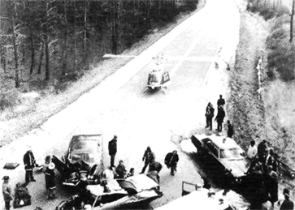
In the second picture, the Coast Guard is helping two boatmen. Their boat is grounded on rocks, and the men have been caught far from land. The Coast Guard rescuers are lowering lifebelts to the men. The boatmen are going to climb into the cage; in the cage they're going to ride Photo twit IPS
up to the helicopter. Then they're going to put on dry clothes and drink some hot coffee. The boatmen hadn't been looking carefully at the sea when they ran into the rocks. They're probably not going to make that mistake a second time!
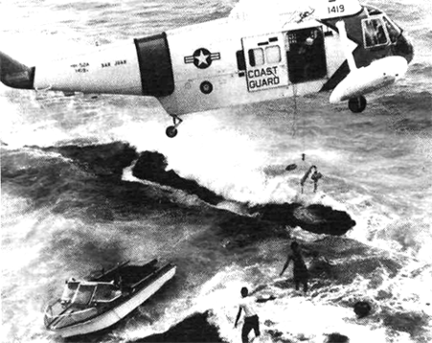
Source: Courtesy 19S9 Kodak International Newspaper Snapshot Awards.
Photo by Mrs. Gloria Gurian

Questions
1. Why can helicopters make so many rescues on land and on sea?
2. Why did the cars have an accident?
3. What are the rescue workers going to do first?
4. How are the injured people going to reach the hospital?
5. Why are the two boatmen standing on rocks?
6. Who is going to help the boatmen?
7. How are the boatmen going to reach the helicopter?
8. What are the boatmen going to do in the helicopter?
9. Why did the boatmen have an accident?
10. Are they going to have another accident like this in the future?

Time Markers
Another future tense in English is formed with the verb be + going to + verb. It has the same time picture as the future tense with will + verb, and the same time markers are also used. Some time markers that describe events that are going to happen in the near future are: soon, right away, in just a minute.

Rescue workers are going to help the injured people right away.
There is still another future tense for actions that are going to happen in the immediate future. It is formed with be + about to + verb. Additional time markers are usually not used in this construction, since the meaning of the tense itself is “soon” or “right away.”

The boatmen are about to receive help from the Coast Guard.
Use each time marker and verb below to make a sentence about the story. Use one of the two future tenses above.
1. rescue workers / give help / about to
2. rescue workers / carry injured people to the helicopter/soon
3. helicopter pilot / take them to the nearest hospital / right away
4. receive medical help / as soon as possible
5. Coast Guard rescuers / help / boatmen / immediately
6. boatmen / put on lifebelts / about to
7. boatmen / get into cage / next
8. ride up to the helicopter / soon
9. drink coffee and put on warm clothes / in a few minutes
10. make the same mistake / never again

Clauses as Time Markers
Two sentences in the future tense can be combined to make a single sentence; however, the time clause must then be in the present tense, (see chapter twenty for a review.)
Combine the following pairs of sentences into one sentence. Use a present tense after the time marker when.
1. I'm going to feel better. I'm going to get off these rocks.
I'm going to feel better when I am off these rocks.
2. I'm going to drink a cup of coffee.
I'm going to be in the helicopter.
3. I'm going to put on some warm clothes.
I'm going to be in the helicopter.
4. The doctor is going to check me.
I'm going to reach the hospital.
5. I'm going to call my wife.
I'm going to find a telephone.
6. I'm going to be more careful.
I'm going to drive my boat.
7. I'm going to put on a lifebelt.
I'm going to drive a boat.
8. I'm going to watch carefully.
I'm going to be on the water.

Time Lines
Make sentences with the verbs below. Use the tense which is indicated in each time line.
had been going
1. 2.
have rescued lost
hit
3. 4.
were hurt need
5. 6.
going to give going to take them helping
first aid to the hospital
7. 8.
are lowering are going to climb, ride, put on
had not been looking
9. 10.
( )

ran are not going to make

Dialogue Between Rescue Workers and the Control Station
Choose a partner and complete the dialogue below.
Pilot: Coast Guard to Control. Come in, Control.
Control: We read you, Coast Guard. Have you found the men yet?
Pilot: Yes, we have. We're right over them now. They look all right. They're grounded on some rocks.
Control: Good. What are you going to do first?
Pilot:
Control: Are they going to need a ride back?
Pilot:
Control: How are you going to get them into the helicopter?
Pilot:
Control: Are they going to need medical help?
Pilot:
Control: What help are you going to give them in the helicopter?
Pilot:
Control: When are you going to be finished? We have another call for help ten miles south of there.
Pilot:
Control: I'm going to call another helicopter. Let us know if you have any problems.

Changing Times, Changing Tenses
Review the pictures and the story in chapter eleven, “Rescue Workers Saved Four People.” Pretend that you are a rescue worker with radio connections to a hospital control station. You have just arrived at the accident. Write a dialogue with the control station, telling what you are going to do to save the people.

Pronunciation
In spoken English, the auxiliary verb and the infinitive to in going to / going tu / are very frequently reduced to the pronunciation /gənə/.
Practice the sentences below.
1. We're going to give first aid to the injured people.
2. Are you going to bring them to the helicopter?
3. Where is the helicopter going to take them?
4. They're going to get medical help at the hospital.
5. Who is going to help the boatmen?
6. They're going to ride up to the helicopter.
7. What are they going to ride in?
8. How are you going to help them get warm?

Unit Nine: The Future Continuous Tense

chapter twenty-two WHEN THE TORNADO HITS
the future continuous tense  WILL + BE + VERB + ing | vocabulary:  wrap hide  blanket chicken  puppies squawk  storm cellar barn

Reading Selection
Listen to the teacher read the selection. Then repeat as the teacher reads in phrases.
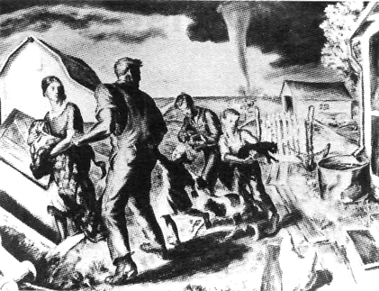
A tornado is about to strike this family's farm. It's moving quickly towards them, but luckily they've already seen it conning. The mother has wrapped the baby in a blanket; the father has called all the children. The two boys are carrying some of the animals: a cat and three puppies. The family is rushing into the storm cellar, where they'll be safe under the ground.
When the tornado hits, they'll be sitting in the storm cellar. They won't be moving around; they'll be hiding in the safest part of the cellar. The mother will still be holding the baby, but the animals will probably be running around, making noise.
Source: OWI Artist John Sluart Curry, Hack ley Art Gallery.
Each person will be listening to the sounds of the storm. They'll hear chickens squawking, and they'll hear the wind blowing. They'll all be thinking about the farm and asking themselves questions about it:
“What will the farm look like when we come out of the storm cellar?”
“Will the house still be standing?”
“Will the barn still be standing?”
“Will all the animals be alive?”
“Will it be raining very hard?”

Questions
1. How soon will the tornado strike the farm?
2. Will the family have time to reach safety?
3. Where will they go?
4. What preparations have they made?
5. What will they be doing when the tornado hits?
6. What will they be thinking about?

Time Markers
Like the past continuous tense, the future continuous is generally used to set up a background activity that is in progress when another action takes place. For example, “I'll be sitting in the storm cellar when the tornado hits.” In the time line, the circle represents the activity of sitting; the X stands for the point in time when the tornado will hit.
will be sitting

hits
The word when is often used to introduce another future action at a specific point in time. Also, the future continuous is often used with specific time markers (clock time, for example) to tell what a person will be doing at some point in the future. Common time markers are combinations with at (at 5:00), with next (next year, next week) and in (in two days, in a month). Notice that the tense in the when-clause does not agree with the time; although we mean future time, we use the present tense.
One other tense picture for future continuous shows two activities which are happening during the same period of time.
will be thinking

are sitting
The family will bethinking about their farm while they are sitting in the storm cellar.
Both verbs express continuous action, but only the verb in the main clause is in the future continuous tense. The dependent clause is introduced by the conjunction while, and the verb is in the present continuous tense.
Join the sentence pairs below with the conjunctions when or while.
1. They will be running into the storm cellar.
The tornado will be moving towards them.
They will be running into the storm cellar while the tornado is moving towards them.
2. The tornado will hit the farm.
They will be sitting in the storm cellar.
When the tornado hits the farm, they will be sitting in the storm cellar.
3. The mother will be wrapping the baby in a blanket.
The father will be calling the older children.
4. The boys will be carrying some animals.
The family will be rushing into the storm cellar.
5. The tornado will hit the farm.
They won't be running around.
6. The mother will still be holding the baby.
The animals will be running around and making noise.
7. They will be thinking about their animals.
They will hear the tornado.
8. The wind will still be blowing.
The family will come out of the storm cellar.
9. They will be coming out of the cellar.
The rain will start.
10. They will be looking at the farm.
They will come out of the cellar.

Noncontinuous Verbs
As you have learned, some verbs cannot be used in the continuous tenses. (See chapter six for a review.) When you are speaking or writing about future time, such verbs will take the simple future tense.
Listen to the following sentences as your teacher reads them. Change each verb to future continuous if you can. If the verb does not take a continuous tense, repeat the sentence as it is.
1. The tornado will move quickly.
2. The family will see the tornado in time.
3. They will rush into the storm cellar.
4. They will all be safe there.
5. The mother will hold the baby,
6. The boys will have their animals.
7. The family will hide from the dangerous wind.
8. Everybody will listen to the storm.
9. They will hear the sound of the wind.
10. They will think about their home.
11. The farm will look very different.
12. It will rain very hard.

Time Lines
Make sentences with the verbs below. Use the tense which is indicated in each time line.
1. 2.
about to strike is moving
3. 4.
have seen has wrapped
5. 6.
are carrying are rushing
will be sitting will be hiding
7. 8.
hits hits
will be holding
9. 10.
are running will be listening
11. 12.
will hear will be thinking about

Changing Times, Changing Tenses
Pretend that the tornado has already hit the farm and the family has come out of the storm cellar. Hold an interview with each member of the family, askfng “What were you doing when the tornado hit?”

UNIT TEN The Future Perfect Tenses

chapter twenty-three PIT STOP AT THE RACE TRACK
the future perfect tense  WILL + HAVE + PAST PARTICIPLE | vocabulary:  auto pull off  speed pit  track check  depend fuel  team

Reading Selection
Listen to the teacher read the selection. Then repeat as the teacher reads in phrases.
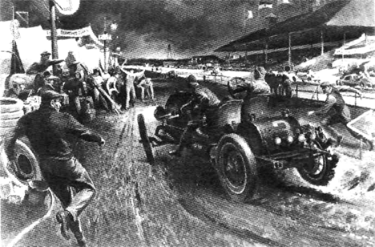
Cars in auto races move at very fast speeds around the track. Some of the races are hundreds of miles long. The drivers try to keep their cars near top speed the whole time. Of course, high speeds are very hard on the cars. Often parts break or wear out during the race.
The race driver depends on the other men on his team, the mechanics who take care of the car. Mechanics never race, but they share in the joy of winning. Their job is to make sure the car will last long enough to finish the race. An old saying goes, “To finish first, first you must finish.”
Source: Esquire Magazine Artist Peter Helck
This driver is pulling off the race track, into the pit. The mechanics are already running to help. When the driver enters the race again, the mechanics will have put fuel in the car. They'll have changed some of the tires. They'll have checked the oil. Perhaps they'll have added more oil. They'll have repaired any problems in the car. The driver will not have rested long, though—the mechanics will have finished all this work in less than one minute!

Questions
1. Why do race cars break down during races?
2. Who takes care of the race cars?
3. What will happen if a car doesn't finish the race?
4. After the pit stop, will the car need fuel?
5. After the pit stop, will the car need oil?
6. How will the tires work after the pit stop? Why?
7. How will the engine work after the pit stop? Why?
8. Why do the mechanics move so fast?

Time Markers
The future perfect tense has two uses. One is to show a completed action which happens before a second action in the future. The future perfect is used with the action that happens first. The other action is often introduced by a time word such as wften, by, or before, and takes a present tense.

will have checked leaves
The mechanics will have checked the car when it leaves the pit.
The mechanics will have checked the car by the time that it leaves the pit.
Chronological order words are not necessary with the future perfect tense, since the tense meaning itself expresses two different times. Notice the different time lines for these sentences.
The mechanics will check the car before it leaves the pit. (The word before is necessary since the future tense does not, by itself, indicate two times.) | check leave

The mechanics will have checked the car when it leaves the pit. (The tense itself indicates two different times, so the word when may be used.) | will have leaves  checked

check  leave | The mechanics will check the car when it leaves the pit. (Nothing in this sentence indicates that the actions happen at different times. In fact, they happen at the same time.)

Interpreting Future Perfect Sentences
Read the sentences below. Tell which action happened first and which action happened next.
1. The mechanics will have worked on the car before the race starts.
First the mechanics will work on the car.
Then the race will start.
2. The mechanics will have repaired some parts when the race is over.
3. They will have put on eight new tires when the race is over.
4. They will have put out their cigarettes when they start to work on the car.
5. They will have put in fuel by the time the car leaves.
6. The driver will have rested for one minute when he starts again.
7. The driver will have gone 500 miles by the time he stops.
8. The team will have received a prize when they go home.

Listening Discrimination
Tell whether the two parts of the sentence will happen at the same time or at different times.
1. The mechanics will work on the car when the race starts.
2. The mechanics will have worked on the car when the race starts.
3. They will fix some parts when the race is over.
4. They will put out their cigarettes when they work on the car.
5. They will have put on eight tires when the race is over.
6. They will have put in fuel when the car leaves.
7. The driver will have rested one minute when he starts again.
8. The team will get a prize when they go home.

Making Sentences in the Future Perfect Tense
Combine the pairs of sentences below to make one sentence in the future perfect tense. Use time words like before, when, and by the time that. Remember that the verb in the time clause must be in a present tense
1. The mechanics will use many new tires.
The race will be over.
The mechanics will have used many new tires when the race is over.
2. They will put in some new engine parts.
The day will be done.
3. The car will use gallons of fuel.
The driver will pull in for the last time.
4. Everybody will work very hard.
The race will be finished.
5. They will earn their money.
They will go home.
6. The driver will drive for ten hours.
The race will be over.
7. The mechanics will help the driver to win.
The day will be done.
8. They will receive a large amount of money.
They will go home.

Changing Times, Changing Tenses
Talk about some of the stories from previous chapters in the future perfect tense.
Chapter four: What will the children have done to prepare for Hallowe'en?
Chapter fifteen: What will the family have done to prepare for Thanksgiving?
Chapter twenty: What will the car companies have added to their new cars by the time the cars are ready to buy?
Chapter twenty-two: What will the family have done to prepare for the tornado?

Pronunciation
In spoken English, the auxiliary verbs for this tense are often pronounced in reduced forms. In positive statements, will have becomes / wɪl ̑əv / or / wɪlə /. In negative statements, won't have becomes / wont ̑əv / or / wontə /. When a pronoun or a question word is the first word in the sentence, the auxiliary verbs are reduced even further.
Pronounce the sentences below.
1. The mechanics will have put fuel in the car.
2. The driver won't have rested long.
3. He'll have rested for one minute.
4. They'll have fixed the engine.
5. Who will have finished first?
6. When will they have finished?
7. What will they have won?
8. How much will they have won?

chapter twenty-four RUN FOR THE MONEY
the future perfect tense  WILL + HAVE + PAST PARTICIPLE | vocabulary:  marathon  prize  stopwatch

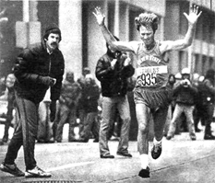
Reading Selection
Listen to the teacher read the selection. Then repeat as the teacher reads in phrases.
Today at 7:30 a.m., 840 runners began their marathon race around the city. Most of them will stay in the race to the end. The prize is money—enough money to pay for a trip to another race!
Now it's ten o'clock, and the winner has just crossed the finish line. His time was two hours, thirty minutes, and 25 seconds.
The man with the stopwatch is clocking the race. He'll have clocked a different finishing time every few minutes for two hours, when the last runner comes in.
The other runners are still racing. They'll finish the race at different times. Some will have run for three hours; some will have run for three and one-half hours; and some will have run for much longer.
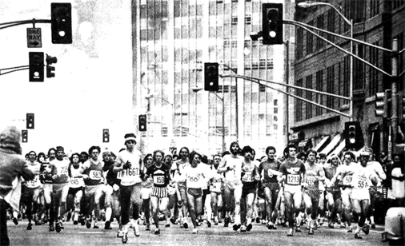
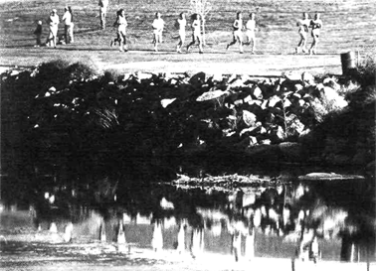
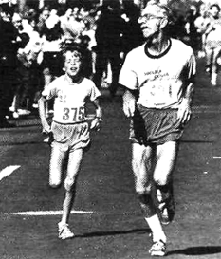
When they finish, they'll be very tired. They'll have run half the time through city streets. The streets were closed to traffic, so they won't have run into any cars. The rest of the time they'll have run along the river.

Each runner will have used his own special method to keep going. The young boy counts the miles. He'll have counted one mile every seven minutes. The older man watches for friends. He'll have seen a number of people finish before him, but he doesn't care. He'll have run every marathon race for thirty years when this race is over. He hasn't ever won any prizes for speed, but he'll have finished more races than any other runner. Today alone he'll have run twenty-six miles, the length of the marathon race.

Questions
Finish the questions below by asking about the story. Then answer each question.

1. When did ...
2. How many runners will...
3. What is ...
4. Who has just..
5. Who is...
6. How often will.
7. What are ...
8. When will...
9. How long will...
10. Where will...
11. How will...
12. How many miles will

Time Markers
The future perfect tense can describe a state, an activity, or a period of time before a second action in the future. When it is used withdurative verbs, the length of time is clearly shown. Usually two time markers appear in these sentences: one for the length of time, and one for the endpoint.

started will have run finishes
He will have run for three hours by the time he finishes.
(duration) (endpoint)
The future perfect can also be used with punctual verbs. In this case, the time picture indicates repeated actions within a period of time before a second action in the future. Two time markers—and sometimes even three time markers—are needed to describe this time picture.

will have clocked finishes
He'll have clocked a different finishing time
every few minutes for two hours when the last runner finishes.
(frequency) (duration) (endpoint)
Make sentences which include these time markers.
1. for two and one-half hours when he crosses the finish line
2. for three hours when they finish
3. for three and one-half hours by the time they finish
4. for a long time before they are through
5. half the time
6. the rest of the time
7. until the end
8. every seven minutes for the length of the race
9. every few minutes for two hours
10. every marathon race for thirty years when this race is over

Time Lines
Make sentences with the verbs below. Use the tense which is indicated in each time line.
1. 2.
began has just crossed
3. 4.
is is clocking
5. 6.
are racing will finish
7. 8.
will have run counts
9. 10.
will have counted will have clocked

Changing Times, Changing Tenses
Retell the story in this chapter in past time, using the past tense and the past perfect tense.
Retell the story in chapter twenty-two, “When the Tornado Hits,” using future and future perfect tenses.

chapter twenty-five TOO LITTLE, TOO LATE
the future perfect continuous tense  WILL + HAVE + BEEN + VERB + ing | vocabulary:  area  blaze  pump  hose

Reading Selection
Listen to the teacher read the selection. Then repeat as the teacher reads in phrases.
This morning at five o'clock, the Green Mountain Restaurant caught on fire. Nobody noticed the fire until six o'clock, when the house next door started to burn. Firefighters came from all over the area. They began to fight the fire at seven o'clock. Now it's eight o'clock, and
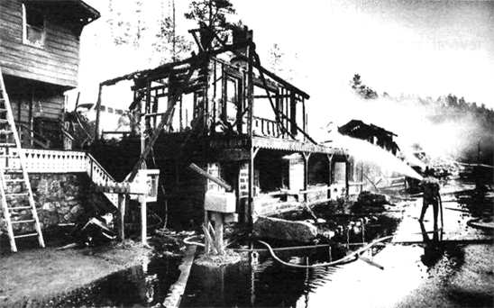
the fire is still going strong. The firefighters are working hard, but they haven't brought the blaze under control yet. Every few minutes they call for more help.
Fire Chief Brown says that in another hour they'll have put out the fire in the house. At that time, the house will have been burning for three hours. Half the house will be gone. Chief Brown is afraid that the fire in the restaurant may go on until ten o'clock. Before it's out, the restaurant will have been blazing for five hours. Every few minutes, part of the building falls in.
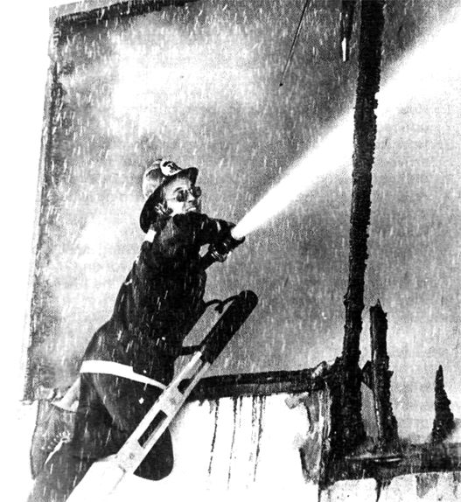
Firefighters will have been fighting the fire in the restaurant for three hours. They'll have been pumping water out of Green Mountain Lake to put out the fire. They'll have been holding their hoses on the fire the whole time. However, the fire will have been burning too long. By the time the fire is under control, nothing will remain of the restaurant. The firefighters will have been working with all their strength, but it will have been too little and too late.

Questions
1. How long had the restaurant been burning before somebody noticed it?
2. How long had the house been on fire before the firefighters arrived?
3. Which fire will the firefighters put out first?
4. How long will the house have been burning when the fire stops?
5. What will the house look like?
6. How long will the restaurant have been burning at ten o'clock?
7. How long will the firefighters have been working?
8. What will they have been doing to put out the fire?
9. Why will the owner lose his restaurant?
10. Should the restaurant owner be angry with the firefighters?

Time Markers
The future perfect continuous is a complicated tense. Durative verbs in this tense involve a beginning, a period of time, and an end point. They relate to another time in the future. Two time markers are usually required in this time picture, one for the duration of the time period and one to mark its endpoint.

started to work will have been working will stop
They will have been working for three hours at that time.
(duration) (endpoint)
When punctual verbs are used in the future perfect continuous, they indicate repeated action within a time period. As many as three time markers can be used: one for frequency, one for duration, and one for the endpoint.

started will have been will be out
to call calling
They will have been calling for help every few minutes for several hours by the time
(frequency) (duration) (endpoint)
the fire is out.
Make sentences which include these time markers.
1. for three hours at that time
2. for five hours by ten o'clock
3. every few minutes for three hours by the time the fire is out.
4. for three hours when they are finished
5. the whole time
6. too long by that time

Interpreting Sentences
For each sentence, tell when the activity started, how long it will continue, and what will happen next.
1. Our neighbors will have been watching the fire for four hours by ten o'clock, when it is out.
The neighbors started to watch the fire at six o'clock.
They will watch it for four hours.
They will stop at ten o'clock, when it is out.
2. The firefighters will have been working three hours at that time.
3. The restaurant will have been burning for five hours by ten o'clock.
4. The house will have been burning for three hours by nine o'clock, when the fire is out.
5. The firefighters will have been working for two hours by nine o'clock.
6. They'll have been pumping water the whole time the fire burns.

Time Lines
Make sentences with the verbs below. Use the tense which is indicated in each time line.
started to burn
1. 2.
caught noticed
3. 4.
began to fight is burning
5. 6.
( )

haven't brought will have put out
7. 8.
will have been burning will be gone
9. 10.
will have been working will have been holding
11. 12.
will have been pumping will remain

Changing Times, Changing Tenses
Retell the story in chapter twenty-four, “Run for the Money.” Use the future perfect continuous tense whenever possible.

